**PAMANTASAN NG LUNGSOD NG VALENZUELA**

Tongco St., Maysan Valenzuela City

College of Engineering and Information Technology

Valenzuela Information Technology Society

DEVELOPMENT AND EVALUATION OF BYTES OF PAST: A 2D ANDROID-BASED EDUCATIONAL MULTIPLAYER CARD GAME ABOUT ICT-RELATED HISTORY TOPICS TO GRADE 9 STUDENTS OF MAYSAN NATIONAL HIGH SCHOOL

A Thesis

Presented to the Faculty of the

College of Engineering and Information Technology

In Partial Fulfillment

of the Requirements for the Degree

Bachelor of Science in Information Technology

BAUTISTA, ANTHONY D.

CANTILLON, IVAN CHEDRICK C.

CHING, CHRISTIAN KYLE T.

PINEDA, JOHN PAUL O.

FEBRUARY 2022

Recommended by:

**Ms. Rosalie P. Alejandro** Date: ____________

Lecturer

Approved in the partial fulfillment for the Degree of Bachelor of Science in Information Technology by the Oral Examination Committee.

____________________________ ____________________________

**Mr. Christopher Cunanan Ms. Mary Grace Nulud-Gonzales**

Panel Member Panel Member

____________________________

**Mr. Patrick Luis Francisco**

Panel Chair

Accepted as partial fulfillment of the requirements in the course Capstone 2 with the grade of ________.

____________________________ ____________________________

**Mr. Patrick Luis Francisco Engr. Jordan N. Velasco**

Chairperson, CEIT Dean, CEIT

**TABLE OF CONTENTS**

CHAPTER 1 1

1.1 Project Context 1

1.2 Problem Statement 3

1.3 Objective of the Project 4

1.4 Purpose and Description 5

1.5 Scope and Limitation 6

1.5.1 Scope and Delimitations 6

1.5.2 Limitations 8

1.6 Definition of Terms 9

1.7 Conceptual Framework 11

CHAPTER 2 13

2.1 Related Literature 14

2.2 Related Studies / Systems 17

2.3 Project Synthesis 21

CHAPTER 3 23

3.1 Development Model 23

3.2 Requirement Analysis 25

3.3 Project Description 28

3.3.1 Student Profile Module 28

3.3.2 Student Assessment Test Module 29

3.3.3 Card Game Module 29

3.4 Project Design 30

3.4.1 Proposed System Context Diagram (0 Diagram) 31

3.4.2 Proposed System Level 1 Diagram 32

3.4.3 Proposed System Level 2 Diagram 33

3.4.4 Use Case Diagram 39

3.4.5 Use Case Scenario 40

3.4.6 Extended Entity Relationship Diagram 50

3.4.7 Data Dictionary 52

3.4.8 Screenshots 55

3.5 Testing and Evaluation Plan 64

3.5.1 Entry Criteria 66

3.5.2 Exit Criteria 66

3.5.3 Schedule 66

3.5.4 Test Cases 67

3.5.5 Evaluation Tool 70

3.5.6 Data Categorization 72

CHAPTER 4 74

4.1 Results 74

4.1.1 Evaluation for IT Experts 74

4.1.2 Evaluation for End Users 75

4.2 Summary of Findings 76

4.2.1 Accuracy 76

4.2.2 Suitability 76

4.2.3 Availability 76

4.2.4 Maturity 76

4.2.5 Learnability 77

4.2.6 Understandability 77

4.2.7 Time Behaviour 77

4.2.8 Resource Utilization 78

4.2.9 Stability 78

4.2.10 Analysability 78

4.2.11 Installability 79

4.2.12 Adaptability 79

CHAPTER 5 80

5.1 Conclusions 80

5.2 Recommendations 81

REFERENCES 83

APPENDIX 85

Excerpts from Curriculum 85

Computer History Museum’s License to Use 88

Data Gathering Results 89

End Users 89

IT Experts 90

Data Gathering Agreement Forms 91

Stakeholder 91

IT Experts 92

Source Codes 97

Multiplayer Game Manager (MPGameManager.cs) 97

Multiplayer Player Manager (PlayerManager.cs) 101

**LIST OF TABLES**

Table 1: Start Game Use Case Scenario 40

Table 2: Exit Game Use Case Scenario 41

Table 3: Create Profile Use Case Scenario 41

Table 4: Host A Game Use Case Scenario 42

Table 5: Join A Game Use Case Scenario 43

Table 6: Choose Topics to Play Use Case Scenario 43

Table 7: Access Game Settings Use Case Scenario 44

Table 8: Access Achievements Use Case Scenario 44

Table 9: Select Gameplay Use Case Scenario 45

Table 10: Start Card Game Use Case Scenario 45

Table 11: Select Card Use Case Scenario 46

Table 12: Use Special Card Use Case Scenario 47

Table 13: Choose Quiz Answer Use Case Scenario 47

Table 14: Quit Card Game Use Case Scenario 48

Table 15: Take Card From the Deck Use Case Scenario 48

Table 16: Trade Card Use Case Scenario 49

Table 17: Take Assessments Use Case Scenario 49

Table 18: ProfileStatisticsData 52

Table 19: AssessmentManager 52

Table 20: QuestionData 53

Table 21: GameController 53

Table 22: Deck 53

Table 23: Graveyard 53

Table 24: Dropzone 54

Table 25: CardData 54

Table 26: Evaluation Results of IT Experts 74

Table 27: Evaluation Results of End Users 75

**LIST OF FIGURES**

Figure 1: Input-Process-Output Diagram 11

Figure 2: Timeline for iPad 17

Figure 3: UNO Card Game for Android 18

Figure 4: Human Immunology Game 19

Figure 5: An Educational game about Biology 20

Figure 6: Digital version of A Brief History of the World by Ragnar Brothers’ 21

Figure 7: Agile - Scrum 23

Figure 8: Context Diagram of the existing process 25

Figure 9: Level 1 Diagram of the existing process 27

Figure 10: Context Diagram of Bytes of Past 31

Figure 11: Level 1 Diagram of Bytes of Past 32

Figure 12: Level 2 Diagram (Take Assessment Exam) 33

Figure 13: Level 2 Diagram (Play Single Player) 34

Figure 14: Level 2 Diagram (Setup Player Profile) 35

Figure 15: Level 2 Diagram (View Player Profile) 36

Figure 16: Level 2 Diagram (Play Multiplayer) 37

Figure 17: Level 2 Diagram (Update Game Settings) 38

Figure 18: Use Case Diagram of Bytes of Past 39

Figure 19: EERD of Bytes of Past 50

Figure 20: Loading Screen 55

Figure 21: Main Menu Screen 56

Figure 22: Topic Select Screen 56

Figure 23: Difficulty Select Screen 57

Figure 24: Assessment Test Screen (Pre or Post) 58

Figure 25: Single Player Game 59

Figure 26: Multiplayer - Create or Join Screen 59

Figure 27: Tutorial 60

Figure 28: Multiplayer Game 61

Figure 29: Game Settings Screen 61

Figure 30: Profile Statistics Screen 62

Figure 31: Achievements Screen 63

**PAMANTASAN NG LUNGSOD NG VALENZUELA**

Tongco St., Maysan Valenzuela City

College of Engineering and Information Technology

Valenzuela Information Technology Society

DEVELOPMENT AND EVALUATION OF BYTES OF PAST: A 2D ANDROID-BASED EDUCATIONAL MULTIPLAYER CARD GAME ABOUT ICT-RELATED HISTORY TOPICS TO GRADE 9 STUDENTS OF MAYSAN NATIONAL HIGH SCHOOL

A Thesis

Presented to the Faculty of the

College of Engineering and Information Technology

In Partial Fulfillment

of the Requirements for the Degree

Bachelor of Science in Information Technology

BAUTISTA, ANTHONY D.

CANTILLON, IVAN CHEDRICK C.

CHING, CHRISTIAN KYLE T.

PINEDA, JOHN PAUL O.

FEBRUARY 2022

# CHAPTER 1

THE PROBLEM AND ITS BACKGROUND

## 1.1 Project Context

Gamification of learning has been used in institutions as an alternative way of the more conventional lecture style teaching. With the known benefits of playing games such as increased cognitive skills and enhanced engagement to the player, integrating it to class learning brings these benefits along with educating the player with the main theme of the game. As technology advances with time, our way of learning and education should also keep up with the available resources to keep the interest of younger minds towards learning. With this knowledge, incorporating gamification with multiplayer modes further enhances the learning experience by having their colleagues join and collaborate. Moreover, the card game genre is also useful as not to encourage players (in this case students) to focus on other game elements (such as combat fights with other types of games), but rather focus on strategy and factual knowledge presented to them with the cards. Altogether, this alternative way of teaching can be utilized to teach topics that students often find lackluster, such as topics involving history.

The project aims to be used by Grade 9 students for their Information and Communication Technology (ICT) subject. These students comprise 10 sections, each having 40 to 45 students (400 to 450 overall). Located at 104 Maysan Road, Maysan, Valenzuela City, the public institution educates Junior High School students residing in Valenzuela City. The current system of teaching involved a modular approach, as compliance to the K to 12 Program. There are no official reference textbooks provided, but rather students are encouraged to do their self-research (often using the web) for references to be presented in class. In addition, this program encouraged students to interact with their classmates in a Presentation / Reporting with Activity approach. The teacher / instructor’s main goal is to guide the students about the learning process, making sure that they are still on track to the topic at hand.

The modular approach of teaching, which involves presentation of a student in front of the class, makes the engagement and attention of the whole class more difficult to achieve (as opposed to having the teacher speak in front). The students’ attention span on these types of topics (i.e. history) are often reduced, making engagement among the class difficult to establish. Moreover, the lack of an official resource increases the risk of inaccurate data being taught to students. Lastly, motivation among students can be increased by implementation of achievements, which the players can then use for competitiveness within multiplayer gameplay.

With the aforementioned conditions, the proponents seek to bring improvements by introducing gamification to teaching educational lessons, more specifically, developing Bytes of Past: A 2D Android-based Educational Multiplayer Card Game About ICT-related History Topics to Grade 9 students of Maysan National High School. Introducing gamification in their lectures seek to improve cognitive abilities by presenting history with graphics and brief facts that will be enhanced by simple card game mechanics. Engagement in class learning is also expected to be improved by introducing multiplayer gameplay to the project, making the learning more desirable to the students. Moreover, this project promotes the use of a single, unified reference for the topics to prevent possible confusion of different students using different references for presenting these topics to their class.

## 1.2 Problem Statement

One of the common problems related in teaching history to the students is, the lack of attention given by the class to the discussion, since most of the students view the topic as lengthy and unexciting. This is further seen when the students themselves are the ones who discusses the lesson to their fellow classmates, hence the modular approach of the stakeholder in teaching these introductory lessons. Disinterest among the class lessens the engagement needed for effective collaboration and learning of the topic at hand.

Moreover, the students are allowed to use resources found within the internet. This leads to usage of multiple sources, which increases the chance of including inaccurate data within the discussion. Thus, the proponents’ project aims to use a unified reputable resource approved by the stakeholder to provide consistency within the discussion.

Lastly, student’s motivation is also aimed to be improved by this project. Through the implementation of achievements, students might play the game even more (and thus subconsciously learn about the topic) to unlock certain achievements, and use it in the idea of competitive play among their peers on multiplayer game scenarios.

## 

## 1.3 Objective of the Project

The main objective of the proponents is to develop and evaluate a 2D Android-based Educational Multiplayer Card Game that aims to teach students the ICT-related History Topics for Grade 9 students of Maysan National High School, a public institution located in Valenzuela City.

1. To develop a two-dimensional (2D) Mobile Game that:
   1. Shows the students with brief facts about the ICT-related History Topics such as:
      1. History of Computer
         * From Hewlett Packard’s founded date (1939)
         * Up to the Apple Watch (2015)
      2. History of Networking and Web
         * From telex messaging networks (1933)
         * Up to the mobile web hits the mass market (2009)
      3. History of Software and Languages
         * From the Plan Calculus (1945)
         * Up to the HTML5 (2014)
2. To develop a Multiplayer Card Game with:
   1. Shedding-type card game mechanics.
   2. Chronological-based card gameplay.
   3. Player interaction patterns such as:
      1. Single Player vs. Game
      2. Player vs. Player
      3. Multilateral competition (Free-for-all) of up to 4 players
   4. Implement special action cards
   5. Store pre-assessment and post-assessment scores
   6. Store player statistics in a profile
   7. LAN-based multiplayer
3. To distribute the game with a static WordPress website.
4. To comply with the ISO 25010.

## 1.4 Purpose and Description

Class discussions related to history are often looked upon by most students as a lackluster topic and therefore, students’ engagement with the instructor and their classmates are hindered. Therefore, the proponents seek to develop a two-dimensional, educational multiplayer card (tabletop) game to aid in teaching the students about ICT-related History Topics in a more engaging way. The game would be installable and playable on Android-based smart phone devices, utilizing touch controls. The game shows different computers of the present up to the past, presented in digital cards, with accompanying illustrations and the year it’s made. Furthermore, the use-cases of the game are the following:

1. A player can play in single-player mode, with the main objective of emptying the hand.
2. A player can be joined by one (1) to three (3) more players in a multiplayer session, either in duel mode (Player vs. Player) or Free-for-all (3 to 4 players).

This capstone project aims to help with the following members, both directly and indirectly:

1. **Maysan National High School** – will benefit since they can re-use the game as an educational tool to teach the same topic every year as part of the curriculum.
2. **The ICT instructor** – will benefit by having a class with greater engagement with the topics.
3. **Stakeholder’s Grade 9 students** – The main beneficiary of this project, as they are the ones to play and learn from the game.
4. **Parents of the students (users)** – will benefit indirectly as they will receive better learning for their children’s skills to improve upon.
5. **Project Proponents** - The project’s proponents are also benefited by enhancing their skills in technical and project management.
6. **Future proponents of similar systems** – will benefit by having a reference to base their own improvements upon.

## 1.5 Scope and Limitation

### 1.5.1 Scope and Delimitations

The game has three main gameplay modes, namely (a) Single Player Game, (b) Multiplayer Game, and (c) Assessment Test. The game is a type of shedding card game, where cards represent each invention in the ICT history timeline, with its date of invention and a short description. To win the game, the player must empty their hands of cards. Players should be able to place and order these cards in a so-called “Timeline”, a dropzone where inventions should be ordered chronologically from earliest to latest (left to right). For the Assessment Tests, these consist of 20 multiple choice questions.

For the card games and tests, players can choose among one of the three ICT history timelines, courtesy of Computer History Museum (CHM):

* History of Computers
* History of Networking and Web
* History of Software and Languages

#### Single Player Game Mode

* **Easy Level**
  + Unlimited Lives, 8 starting cards on hand, No quiz rounds
* **Normal Level**
  + 5 Lives, 8 starting cards on hand, Quiz every 5 rounds
* **Hard Level**
  + 3 Lives, 9 starting cards on hand, Quiz every 5 rounds, 45 seconds per turn

#### Multiplayer Game Mode

* **2 to 4 players** with different number of starting cards:
  + 7 cards each player, if there are 2 players
  + 6 cards each player, if there are 3 players
  + 5 cards each player, if there are 4 players
* **Quiz** every 3 rounds. If a player is correct, then discard a random card at their hand
* Players can **trade** their cards with other players, limited to 2 trades per game
* **Special Action Cards**, cards that trigger effects when played correctly
  + **Peek**, shows the invented year of a random card at hand
  + **Double Draw**, makes the next player to commit a mistake to draw 2 cards instead of one
  + **Skip Turn**, makes the next player to play skip their turn

For the Pre-Assessment and Post-Assessment tests, the players are given a twenty (20) items multiple choice quiz with the same questions. Each question has four (4) choices, and are dependent on the ICT history topic chosen by the player.

All the data in the game will be stored locally within the device only, and will not be uploaded to any centralized external databases. This information can then be shared by the students’ using a screenshot of their profile page. These informations include:

* Student’s Name
* Student’s Section
* Student’s Avatar
* Assessment Scores (Pre and Post )
* Card Drop Accuracy (Percentage of correct drops)
* Win and Loss Counts (Single Player and Multiplayer)
* Achievements

The game will be distributed in the form of an Android Package (APK) file, hosted with Github Releases. The download link to the latest version is presented on a static WordPress website. The game will not be published on Google Play Store.

### 1.5.2 Limitations

This project has the following limitations:

* In case of disconnection to the host / server (i.e. device shuts down, losing network connection), clients cannot reconnect to the game.
* The game cannot resume its state of multiplayer if the server encounters problems with its network or the device fails (i.e. shuts down, battery drained, etc).
* In case of accidental termination of the application at single-player game mode, the game cannot resume its previous game. All statistics related to the unfinished game would be discarded.

## 1.6 Definition of Terms

* **Android Package (APK)** – a file type used to install applications on the Android operating system, for the student’s mobile phones.
* **History of Computers** – This will include any major computer-related inventions from Hewlett Packard’s founding date, up to Apple Watch.
* **History of Software** – This will include any software innovations from the Plan Calculus up to the HTML5.
* **History of Networking and Web** – This will include any network and web innovations from telex messaging networks up to the mobile web that hits the mass market.
* **Hosting Architecture** – an architecture/design where a server delivers the data to one or more clients.
* **Information and Communications Technology (ICT)** – part of the students’ curriculum as a subject. This refers to all communication technologies that enable the users to access, retrieve, store, transmit and manipulate information in a digital form.
* **Mirror Networking** –this provides an abstraction layer that makes it easier to implement multiplayer gameplay over the network in a Client-Server configuration.
* **Multiplayer** **game** – a game mode where two (2) or more players can play at the same time.
* **Shedding-type Card Game** – a type of card game in which the players’ aim is to be the first to empty the cards in their hands. The category in which the game falls under.
* **Single-player game/mode** – a game mode where only one user is expected to play the game at any moment in time
* **Theme** – A theme is either of the three available history topics included within the game.
* **Timeline** – a single row of cards where players attempt to place cards about computers ordered by year, from earliest (left) to most recent (right).
* **Unity** – a cross-platform game engine used to develop video games for web plugin, desktop platforms, consoles, and mobile devices.

## 1.7 Conceptual Framework



###### Figure 1: Input-Process-Output Diagram

Figure 1 simply shows the conceptual framework that would be used by the proponents throughout the project. As shown, the concept works following four steps – Input, Process, Output, and Feedback.

The process followed an agile framework called Scrum. The development is portioned into “sprints”, which is a whole cycle of planning, implementing, and review of the project. A scrum master within the proponents’ set tasks in the form of sprint backlogs, which are based on the product backlogs (requirements by the stakeholder), and assigns them with the team members. Tasks of more importance are set with high priority among the list of backlogs, and are done first before the other tasks. Once all the tasks were done, the team gathered and conducted a review of the sprint, assessing what went right and wrong, and what backlogs are not accomplished and is set to be done on the next sprint. After a round of a sprint, the process is repeated. Clarifications can be made with the stakeholder regarding the requirements (product backlog), which are then planned and assigned again by the scrum master as sprint backlogs, done by the team, until the output (project) of a sprint accomplishes all of the requirements and is ready for deployment.

The output received by the teacher of Grade 9 students is a 2D Android-based Educational Multiplayer Card Game that will help the students in learning the ICT-related History Topics. This game would be distributed in an Android Package (APK) that would be installable in the devices of the students.

Finally, feedback is generated upon using the generated output (actual game), which can be used by the proponents and other future proponents of similar systems to improve upon the project.

# CHAPTER 2

REVIEW OF RELATED LITERATURE AND SYSTEMS

**Technical Background**

The core of the project’s development revolves around the game engine. A game engine is a software environment where developers can make multimedia games for platforms such as PC, mobile, or consoles. In this project’s case, Unity, a free game engine by Unity Technologies, has been used. This environment enabled the proponents to bring the elements together required for the card game, such as artworks, audio files (sound effects and background music), to bring the complete experience of such a game. For the visual elements, such as card designs, Adobe Photoshop has been used. This software is a well-known photo manipulation application for creating graphics, with tools that helped the proponents illustrate the historical inventions and events with relation to Computer History. The art style followed a two-dimensional approach, also known as 2D Graphics, where the images are presented such as on a flat surface.

In terms of audio design, the proponents are looking for available free resources on Unity Asset Store, the official store of Unity for different plugins and assets compatible with their game engine. Such audio includes sound effects (SFXs), and background music (BGMs), and is imported to the game. Audacity, a free and open-source audio manipulation software, has been used for minimal editing of these audio files.

Finally, for the multiplayer feature of the game, the proponents used a free third-party library from the Unity Asset Store called Mirror by vis2k. This open-source library abstracts the complicated part of programming a multiplayer scene, and provides easier-to-use tools to accomplish a synchronized gaming experience across different players on a network.

## 2.1 Related Literature

E-learning is an alternative way to a more conventional teaching practice of classroom-based learning. In a study made by Caballero (2000), e-learning still plays a role in developing the skills of the students. However, while the respondents showed enthusiasm in using these e-learning systems, the study indicated that it is not the only factor that made the students learn their lessons easier. On the other hand, this e-learning system pertains to courses/programs that are completely delivered online, which might only include typed texts and pre-recorded video lessons and instructions, and not incorporate gamification. It is also suggested that students find it difficult reading off a digital device for an extended amount of time, opening possibilities for other methods aside from reading for teaching.

According to a book of Kapp (2012), Gamification, unlike traditional games, it does not intend to create a confined space for a player to interact with. Instead, gamification’s intention is to use the elements found in game-like environments to encourage learners in engaging with the content or the topic. As he stated, “Gamification uses parts of games but is not a game”, further reinforces the idea that Gamification is focused on creating a learning environment, but only uses parts of game elements to deliver the lesson. Furthermore, he stated that the best type of interactive learning event (ILE) for testing a learner’s knowledge about facts, is to create a game of matching or problem solving, as opposed to other types such as simulations. Lastly, he also stated that to consider a system under gamification, this system should have some of the core foundational elements such as: Feedback, Constructs, Challenge, and Story. Feedback is a way of informing the learner about something that happened, such as the learner’s performance after a game, or other feedback such as movements and interactions. Constructs define the limitations and/or abilities of the player within the game environment (i.e.Rules, Game Mechanics). Motivation and engagement of learners are stimulated by implementing Challenges that scale as the player progresses. Lastly, Story helps induce eagerness among the learners to find out what would happen next.

Game-based learning has also been adopted by institutions for the past years. This adoption has seen phases of pattern conducted in classes for integration of games to learning, namely, (a) pre-game, (b) game, and (c) post-game (Bado, 2019). The pre-game phase consisted of introductory lectures to the topic, as well as introduction of the game itself. The game phase is where the actual playing of students happens, while post-game is mostly debriefing, and a way for the teacher to make sure that the students related the game played to their actual topic at hand. This study suggests that there is already an ongoing integration of gamification on class-based learning.

Card game, a game played for pleasure or gambling and maybe both that has a primary device of playing cards. These card games are often characterized as games of chance or also called “imperfect information”. According to Parlett (2013), card games are therefore games of “past imperfect information”, which means that it is more significantly increasing one’s information process. There are also different types of card games. One of these is a shedding game. To win the game, players start with a hand of cards and the main objective is that the first player to discard all cards from one’s hand will win the game. Cards easily lead the development of many different games and variations, it’s just like it must be suited according to the skills and temperaments of a person. From simple card game design, together with the developments, many changes happened in card design and the gameplay itself.

Just like historical films, history in digital games has seen a widespread adoption among professional historians. With today’s time, children among this generation tend to not seek information using traditional literature such as books and written manuscripts, but rather seek information first using digital solutions. Incorporating this behavior, with children that mostly want to play digital games, into history, makes historical digital games a viable option to educate young learners about the past. Moreover, history presented as digital games eliminates the need for physical, actual reenactment that would otherwise take more effort to recreate detail and the overall feel of the past. Digital games offer flexibility and have virtually no limitations in recreating past scenes with assets that can be created and revised until the game matches the past (Chapman, 2018).

## 2.2 Related Studies / Systems

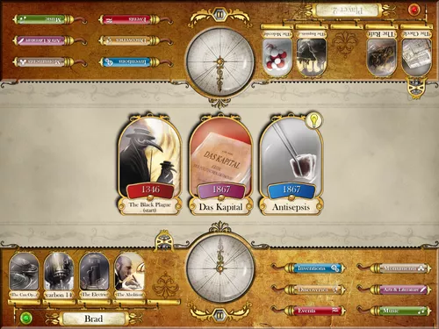

###### Figure 2: Timeline for iPad

Timeline for iPad is a digital version of the Timeline card game by Asmodee. The game makes a player depict the right sequence of historical events, inventions or discovery by playing a deck of cards and arranging it in order of time of the invention or event that took place. This game is the main inspiration of the game researchers are currently developing. Since the main focus of the project is to depict the history of events that lead to the computer technology evolution, the timeline game mechanics suit the purpose. With illustrations in each card and their invented date, the game succeeds in educating its players subconsciously while having a competitive multiplayer experience. However, the project includes short descriptions per invention (card), since historical computers’ function and purpose is not clear when students look at the cards for the first time.

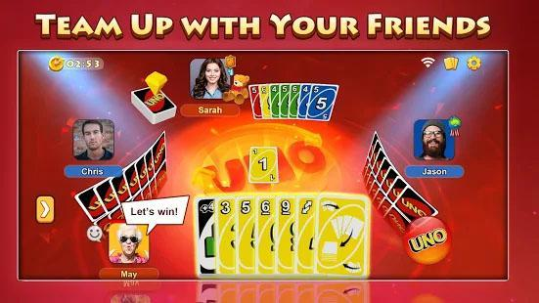

###### Figure 3: UNO Card Game for Android

UNO™ for Android, which is based on UNO by Mattel Games, is a card matching game that can be played by up to 4 players. This project also took inspiration from this game, specifically the special action cards. These special action cards can aid the players to defeat their opponents (other players) often with punishments. The project adopts this concept of special action cards, but instead of the player deciding when to activate the action, the special actions come as a surprise when players’ place their card in the timeline, correctly positioning the card in order, in which time the action is only activated.

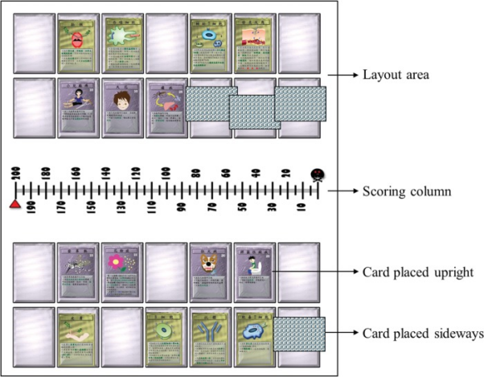

###### Figure 4: Human Immunology Game

In research entitled “Investigating the Effectiveness of an Educational Card Game for Learning How Human Immunology Is Regulated” by Su (2014) shows that an educational card game exhibited many significant advantages for enhancing student learning and their different learning strategies. The card game genre is well structured and so its game rules can be easily integrated with instructional content to make intuitive concepts to the student. Collaboration between their peers has shown their competitive skill in the game because of their will to win against their opponents. In the study, the researchers have made an instructional card game to teach Immunology (Biology) to students, a subject that is often found to be difficult to grasp for students. According to Short (2011), there are various disciplines that are important to the child’s mental development learning and through playing, children not only reflect the cognitive development that they attained but it consolidates the skills, actions and meanings. They presented the instructional content in text and also created a simulated situation that allows learners to actively manipulate different skills and strategies that might be used to construct knowledge and to solve problems. The researchers also concluded that out of the many and various game types, card games are the most advantageous in terms of enhancing the students' learning and believe that card games have the potential to be applied to secondary-level courses.

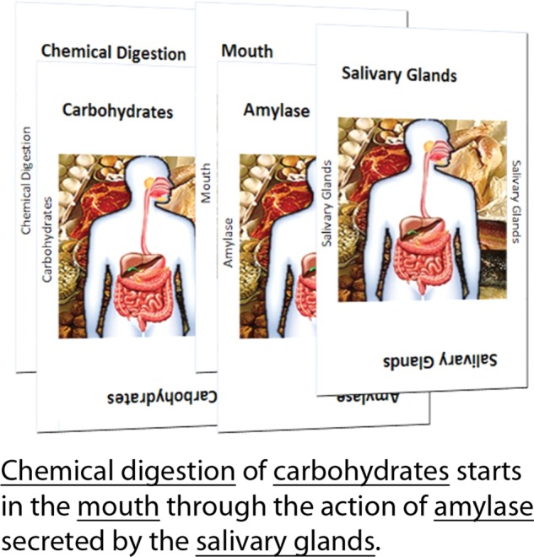

###### Figure 5: An Educational game about Biology

According to Gutierrez (2014) based on the research entitled “Development and Effectiveness of an Educational Card Game as Supplementary Material in Understanding Selected Topics in Biology”, individuals are more likely to learn when they study with other people unlike if they are alone. Most educators said that they are mostly concerned about the students that don’t spend enough time acquiring knowledge and engaging in independent thinking and active learning. Regarding this, they have observed that the most common problem encountered by the students in learning about biological sciences is that they have difficulties in understanding the biological concepts. Many students are discouraged in learning biology because of complex vocabulary that they need to memorize and understand as well. Noted that educational games are more favorable in learning science, the game will help the students to acquire the major problem in biological concepts based on Ellington (1998). Once the lesson has been taught to the students, an exercise will be executed to the class to apply what they have learned through the use of educational card game. Advantage of this is that , they lessen the problem with biological vocabulary and they enjoy learning by playing the game.

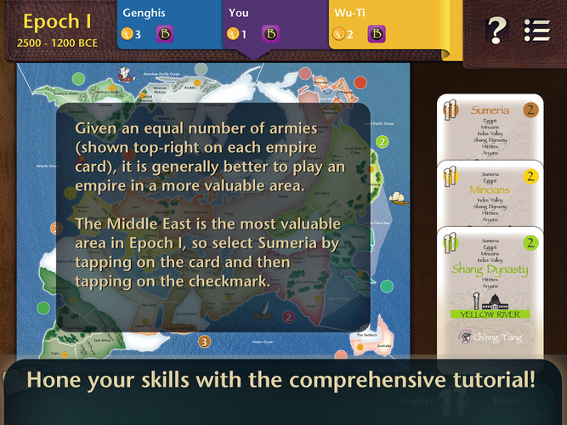 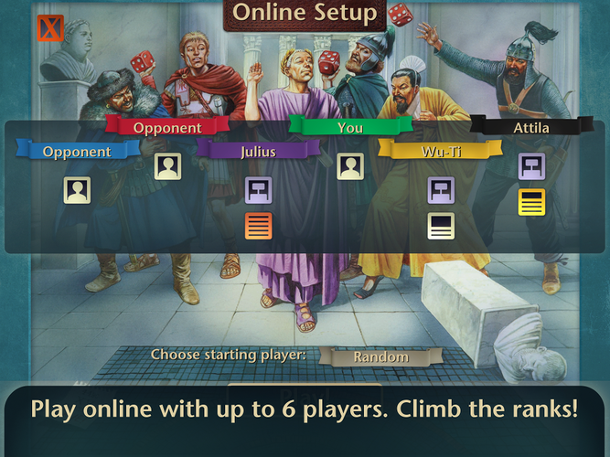

###### Figure 6: Digital version of A Brief History of the World by Ragnar Brothers’

Codito Development Inc. made a digital version of the Ragnar Brothers’ board game, A Brief History of the World. This is a game wherein you will make a trip across the history of mankind by playing the role of some well-known leaders across the globe and conquering various lands by using 40 various event cards. This game can be played as solo against different levels of AI and can also be played by online multiplayer games. Since the focus of the project is to depict historical events in computer evolution, this game is somehow correlated. This game can also help students and other people to learn and understand more about the history of mankind and how the different leaders ruled their nation back then.

## 2.3 Project Synthesis

When looking back to the old days of game, many game developers, designers or other people that are just a hobbyist are able to develop a game, indicating that there are no limits attached when making a game. People can make a game either or whatever the genre is. The proponents will develop an Android-based educational multiplayer card game for the students of 9th grade of Maysan National High School since the idea or the game concept will talk about the timeline or eras of the computers. No game will be exactly copied or duplicated by the proponents in the time being of this project, and only inspirations to create a new, specific targeted game for a unique experience.

# CHAPTER 3

## 3.1 Development Model

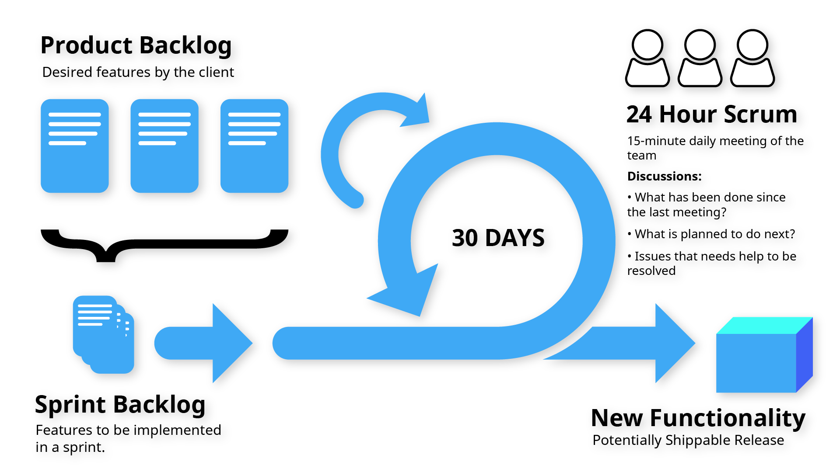

###### Figure 7: Agile - Scrum

This project followed an Agile Development subset called Scrum. In Agile Development, the requirements of a software are ever-changing depending on the needs of the client. Much like in iterative development where the process of gathering requirements up to the release is repeated until the software solution is ready for production or release. This development model also aims to provide better productivity throughout the software’s life cycle, delivering key features in a timely manner.

In Scrum, there are three main roles, namely the Scrum Master, the Product Owner, and the team of developers. The Scrum Master is the person responsible for managing the whole iterative process, involving the Product Owner and the team. They are also responsible for having more extensive knowledge of the process, and are also there to resolve arising issues quickly.

On the other hand, the Product Owner provides the requirements and the desired features to be included in the software. This often comes in the form of a User Story or a Use Case. In a User Story, details about a user’s role, the desired feature, and its purpose are provided. Use cases can also be used, although being more traditional.

The team is the group of developers and other members assigned to do tasks that lead to delivering the software and its features. The members of the team can be diverse to fit software’s requirements.

The process starts in the Product Owner listing their requirements for the software, called the Product Backlog. The Scrum Master chooses from this list provided, and assign them to another list called the Sprint Backlog. A Sprint is a time-bound cycle wherein the requirements in the Sprint Backlog are implemented and done by the team. After a Sprint, the team does an assessment on what worked and what didn’t. A presentation might also be conducted to show the Product Owner the features available already in the software. Necessary adjustments are done with the backlogs, then a Sprint is repeated. Every end of a Sprint, the produced software can be considered potentially shippable (or is ready for release). This cycle repeats as the Product Owner provides more features necessary, or required fixes on the software.

## 3.2 Requirement Analysis

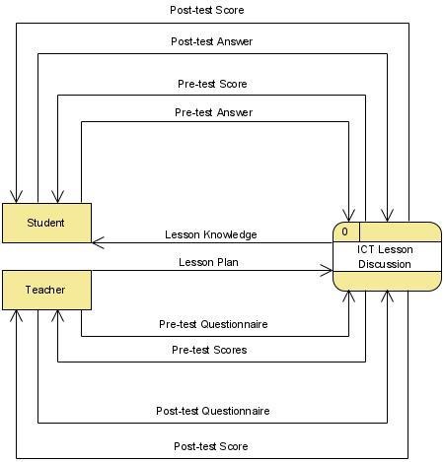

###### Figure 8: Context Diagram of the existing process

The overall process of the current discussion in ICT involves two main entities, the “Teacher” and the “Student”. This process includes student’s participation in Pre-Test and Post-Test Assessment Exams, and the Teacher’s preparation of the Lesson Plan and Questionnaires. Upon the discussion following the lesson plan provided by the teacher, the student is also able to gain knowledge.

The discussion starts after the teacher takes initiative and provides a lesson plan, which will serve as the guide for the whole class in a meeting. This lesson plan can include key notes, ideas, and questionnaires of the assessment exams. These ideas are presented by the teacher to their students, allowing the students to learn and gain knowledge from the discussion.

On Assessment Exams, the students provide their answers to either the Pre-Test or the Post-Test. This is then checked against the lesson plan’s answer key, and the test results are shown back to the students.

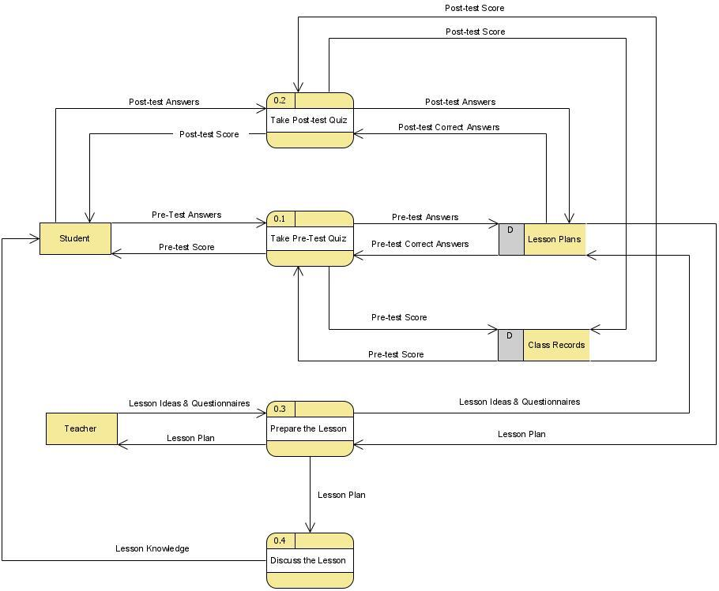

###### Figure 9: Level 1 Diagram of the existing process

On the Level Diagram above, data flow and storage are further expanded. The discussion starts on the teacher’s preparation of the lesson. This is then stored to their collection of Lesson Plans for future reference by other processes. The student’s then take a Pre-Test Exam as a way for the teacher to gauge the students’ existing knowledge regarding the subject. The answers given by the students are then checked against the prepared lesson plan, which will produce a score that is then stored in the Class Records data storage.

The lesson is then discussed to students to deliver the knowledge and obtain the learning objectives stated in the lesson plan. Later on, the teacher conducts a Post-Test Exam regarding the same subject, in which the process and storage remains similar to the Pre-Test process aforementioned.

## 3.3 Project Description

### 3.3.1 Student Profile Module

Profiles are a visual representation of the personal identity of a user. It may consist of any factual data regarding the being of the specific person. It can be Names, ages, or birthdays as long as it is describing the person’s real identity.

In this module, every single player has the ability to create or sign up for an account in order to play the game. Players will fill up the necessary data such as the player’s full name and the corresponding section they’re in. Once they are done signing up, they will be able to matchmake and play the game. Every single game they play is recorded and will be reflected in the player’s profiles.

Upon opening this module, the players will see their name and section and they are also able to see not just how well they play the game but rather find the amusement and great satisfaction of the achievements they got. Lastly, players are also evaluated by other modules and once it is done the Assessment Tests Scores are recorded in this module for the users to be able to see how well they study and play.

### 3.3.2 Student Assessment Test Module

In this module, the player will take the 2 kinds of assessment; pre-assessment and the post assessment test. The assessments will be in the form of multiple-choice quizzes which are playable within the game. Like the traditional multiple-choice quizzes, there are questions to be answered by choosing from the letter a-d. In pre-assessment, this is conducted on the first attempt of the player to play. In post-assessment follows a similar approach, but with a wider scope of questions involved around the theme. In taking the assessment, they will choose what topic/theme they are going to take.

### 3.3.3 Card Game Module

In this module, the player has the decision to pick which of the two (2) modes he wants to play. The two modes consists of the single-player mode and the other one is the multiplayer mode. For the single-player, the player has an opportunity to choose what difficulty he wants to play with. Single-player will consist of a deck of cards, a graveyard, and lives that the player will encounter while playing. The graveyard is where the dumped card goes. The lives will serve as the chances of the player to win the game. The deck of cards is correlated to the graveyard and into the lives. When a player picks a card from the deck, the player can use the card to his advantage to win the game. However, the card he gets can also be placed into the graveyard if the card is not correctly compatible in the timeline. Once the card he placed goes into the graveyard, the player will lose one life. The player must avoid losing all the lives he has to win the game.

For the multiplayer mode, the game will have a lobby that will serve as the place where the players will gather to play the game. This mode will run in a LAN-based multiplayer setting. It means that one player must be the server and the other players must connect to the host of the server in order for them to play the multiplayer mode.

## 3.4 Project Design

The Proposed System’s Context, Level 1, and Level 2 Diagrams are Data Flow Diagrams that show the processes, data stores, entities, and the data that flows in and out of these that visualize the flow of data within the system.

The Use Case Diagram shows the primary actor (primary user) of the system and their available actions within it. This also shows any extending use cases that are either required or optional in completing each use case scenario. These use case scenarios are then enumerated in tables that specify the sequence of events each actor will undergo upon triggering a use case.

The Screenshots show different screen captures of the system (the game) in its different states. These illustrations show the interface and layout of the system while it is installed on a device with the target platform.

### 3.4.1 Proposed System Context Diagram (0 Diagram)

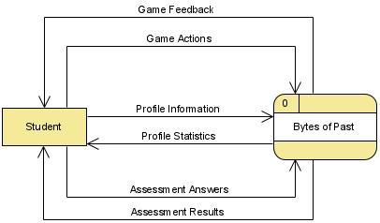

###### Figure 10: Context Diagram of Bytes of Past

The figure above shows the context diagram of the proposed game (system). The student is the main entity that uses the system, and is responsible for providing information such as their profile (name, section), answers to assessment tests (Pre and Post Assessment), and actions within the card game for interaction. These pieces of information are then processed by the proposed system, into which corresponding feedback is then received by the student entity.

### 3.4.2 Proposed System Level 1 Diagram

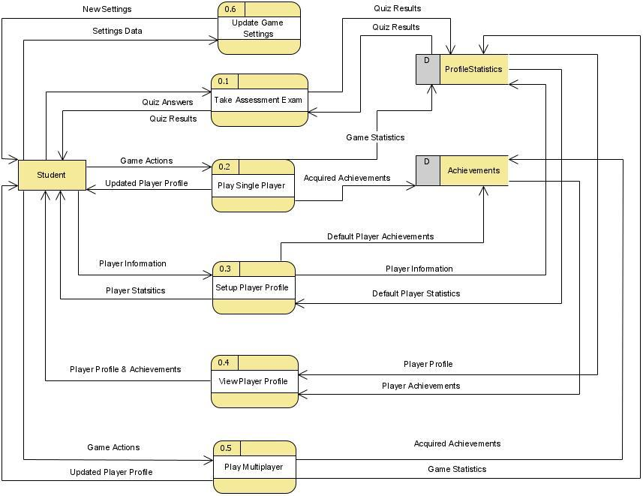

###### Figure 11: Level 1 Diagram of Bytes of Past

The figure above shows the different processes available within the proposed system. Processes such as Taking Assessment Tests, Playing the Card Game, and Setting / Viewing the Player Profile (which includes game statistics, achievements, and test scores). The data store Player Statistics holds the data about the player information (i.e. name, section) and their game statistics (accuracy of played cards, wins / losses). On the other hand, the Achievement data store holds the data for current accomplished achievements within the game.

### 3.4.3 Proposed System Level 2 Diagram

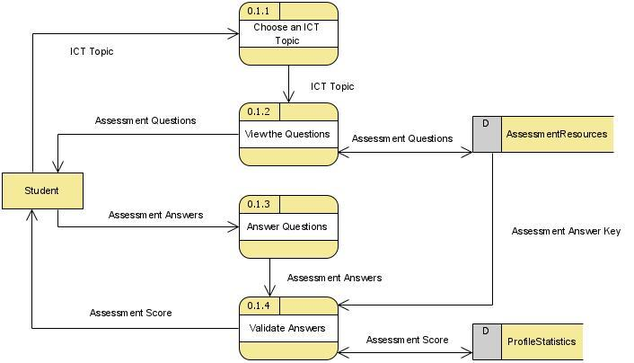

###### Figure 12: Level 2 Diagram (Take Assessment Exam)

The figure above shows the process of taking an assessment exam (either Pre or Post) by the student (player). The student first chooses one from the available list of ICT-related topics. The questions are then gathered for the aforementioned topic from the Assessment Resources data store and are then shown to the student. The student then provides their answers to the questions, which are validated using an answer key from the Assessment Resource. After validation, the student’s test scores are then computed and shown.

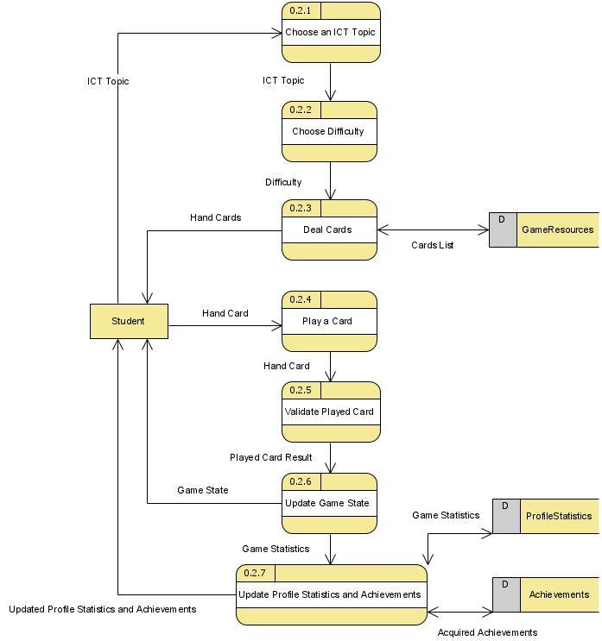

###### Figure 13: Level 2 Diagram (Play Single Player)

The figure above shows the process of playing the actual card game in single player mode. Just like in taking an assessment exam, the student needs to choose first from a list of available ICT Topics. Next, the player should choose a Difficulty level of the game to be started. Then, the process of dealing cards will start and give the player (student) a hand of cards. These cards can then be played by the player, which is then validated if it is a valid play. The result of the play (correct or wrong play) will update the current game state (i.e. game playing or ended), which is also shown to the player. If the game ends, the game statistics will then be used to update the overall player’s profile statistics and achievements, which is also then shown to the player at the end of the game.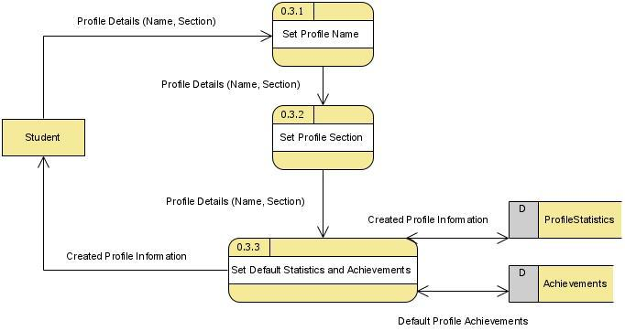

###### Figure 14: Level 2 Diagram (Setup Player Profile)

The figure above shows the process of creating a new profile in the game. The process involves setting the Profile Name and the Section of the Student, after which the default values and state of their profile statistics and achievements are set, respectively. This information is then stored in Player Statistics and Achievement data stores.

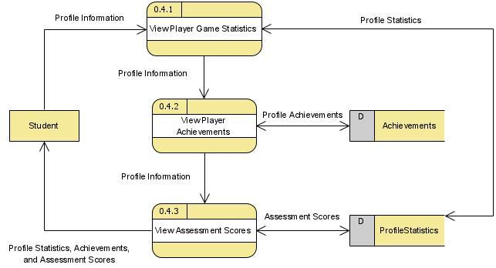

###### Figure 15: Level 2 Diagram (View Player Profile)

The process of viewing a player profile involves getting the game statistics of the player, the current state of their achievements, and their assessment scores, which are also fetched from the Profile Statistics data store and Achievement’s data store. This is then shown back to the student entity.

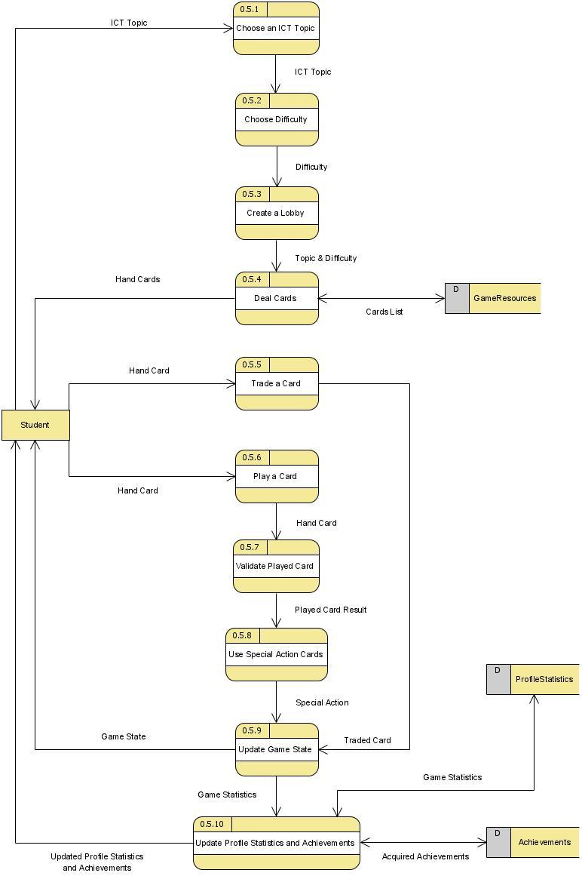

###### Figure 16: Level 2 Diagram (Play Multiplayer)

Similar to the process of playing a Single Player game, the Multiplayer game mode format follows the process of the aforementioned game mode. However, this game mode involves processes of Trading a Card with another player (opponent), and the Use of Special Action Cards. At the end of a game when one player wins the game before other players, the game statistics are updated on each player’s profile data, which are stored in their own Profile Statistics data stores.

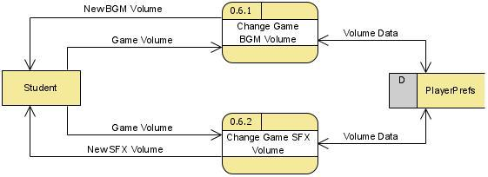

###### Figure 17: Level 2 Diagram (Update Game Settings)

The process of updating the game settings involves 2 processes. Both processes involve modification of the game’s audio volume, with Background Music (BGM) and Sound Effects (SFX), respectively. These volume data are then stored in a PlayerPrefs data store (the game engine’s storage of preferences / settings), which are then also retrievable in succeeding game launches.

### 3.4.4 Use Case Diagram

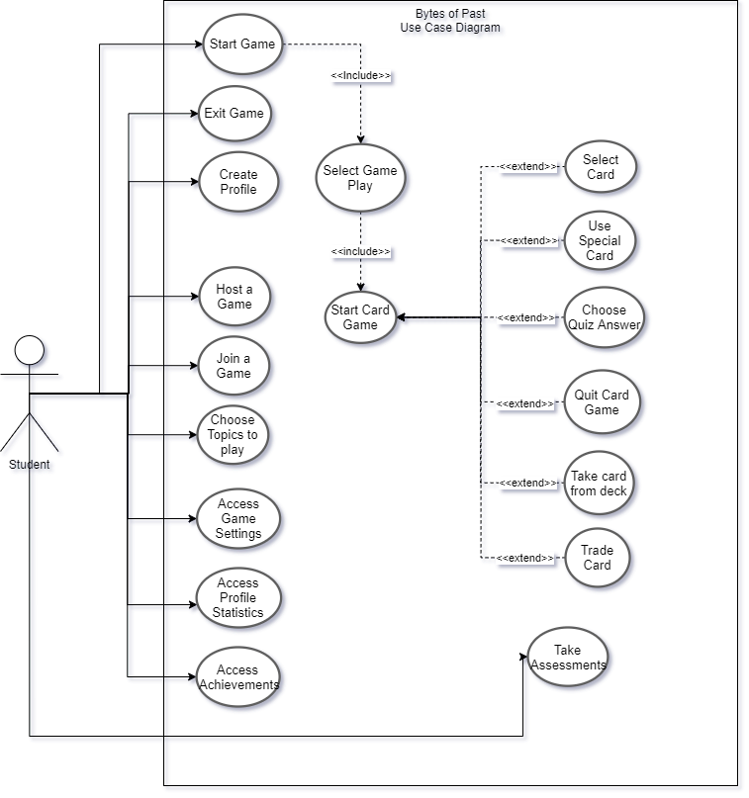

###### Figure 18: Use Case Diagram of Bytes of Past

### 3.4.5 Use Case Scenario

| **NO** | 1 |
| --- | --- |
| **USE CASE NAME** | Start Game |
| **SUMMARY** | The Main Menu Interface of the game will show up. |
| **DEPENDENCY** | NULL |
| **ACTORS** | Student |
| **PRECONDITIONS** | The student has opened the game. |
| **MAIN SEQUENCE** | 1. Students must open the game. 2. Wait for the loading of the game. 3. Students are able to start the game. |
| **ALTERNATE SEQUENCE** | NULL |
| **NON-FUNCTIONAL REQUIREMENTS** | **Performance**  The game will load within a time frame of 5-10 seconds.  **Usability**  Students are able to understand the game since it has a user-friendly interface. |
| **POST CONDITION** | Students are able to see the Main Interface of the game. |

###### Table 1: Start Game Use Case Scenario

| **NO** | 2 |
| --- | --- |
| **USE CASE NAME** | Exit Game |
| **SUMMARY** | The game will be over. |
| **DEPENDENCY** | NULL |
| **ACTORS** | Student |
| **PRECONDITIONS** | Student clicked the quit or exit button |
| **MAIN SEQUENCE** | 1. From the User Interface, The Student will click the Exit Button 2. The Game will be closed. |
| **ALTERNATE SEQUENCE** | Remove the game from task manager of the device |
| **NON-FUNCTIONAL REQUIREMENTS** | **Usability**  Students are able to use it since it is easy to see and understand. |
| **POST CONDITION** | The game will close. |

###### Table 2: Exit Game Use Case Scenario

| **NO** | 3 |
| --- | --- |
| **USE CASE NAME** | Create Profile |
| **SUMMARY** | The student will fill up some information that needed in the game |
| **DEPENDENCY** | NULL |
| **ACTORS** | Student |
| **PRECONDITIONS** | The student clicked the create profile button |
| **MAIN SEQUENCE** | 1. Students are in the Main Interface. 2. Student clicked the Create Profile button |
| **ALTERNATE SEQUENCE** | NULL |
| **NON-FUNCTIONAL REQUIREMENTS** | **Functionality**  The students must enter their legitimate personal details.  **Reliability**  The game will support mature names and won’t show any faulty details. |
| **POST CONDITION** | Students will have their profile created. |

###### Table 3: Create Profile Use Case Scenario

| **NO** | 4 |
| --- | --- |
| **USE CASE NAME** | Host a Game |
| **SUMMARY** | Student will create a lobby for other players to match |
| **DEPENDENCY** | NULL |
| **ACTORS** | Student |
| **PRECONDITIONS** | Students must have their profile created. Connections are set-up. |
| **MAIN SEQUENCE** | 1. A student selected a multiplayer gameplay 2. Clicked the Host a Game button |
| **ALTERNATE SEQUENCE** | NULL |
| **NON-FUNCTIONAL REQUIREMENTS** | **Reliability**  Students should see each other in the lobby. |
| **POST CONDITION** | The students are in lobby and ready to play |

###### Table 4: Host A Game Use Case Scenario

| **NO** | 5 |
| --- | --- |
| **USE CASE NAME** | Join a Game |
| **SUMMARY** | The student can join to other players’ match |
| **DEPENDENCY** | NULL |
| **ACTORS** | Student |
| **PRECONDITIONS** | The students selected what type of game would be joined. |
| **MAIN SEQUENCE** | 1. Students are in the Main Interface. 2. Student clicked either a multiplayer button. 3. Select a lobby and click play. |
| **ALTERNATE SEQUENCE** | NULL |
| **NON-FUNCTIONAL REQUIREMENTS** | **Usability**  It is easy for the students to join because buttons are able to be seen easily.  **Functionality**  The students are able to join a selected game |
| **POST CONDITION** | The student will join a selected game. |

###### Table 5: Join A Game Use Case Scenario

| **NO** | 6 |
| --- | --- |
| **USE CASE NAME** | Choose Topics to play |
| **SUMMARY** | The student decides the topic he want to be the theme of the match |
| **DEPENDENCY** | NULL |
| **ACTORS** | Student |
| **PRECONDITIONS** | The students are on the create match scene. |
| **MAIN SEQUENCE** | 1. From the main interface, 2. Select a mode of gameplay, 3. Select topics that students want to play. |
| **ALTERNATE SEQUENCE** | NULL |
| **NON-FUNCTIONAL REQUIREMENTS** | **Reliability**  Topics shown on the screen are only the proposed ones. |
| **POST CONDITION** | The students selected a topic to play. |

###### Table 6: Choose Topics to Play Use Case Scenario

| **NO** | 7 |
| --- | --- |
| **USE CASE NAME** | Access Game Settings |
| **SUMMARY** | The student can change settings of the game |
| **DEPENDENCY** | NULL |
| **ACTORS** | Student |
| **PRECONDITIONS** | The game is on Main Interface |
| **MAIN SEQUENCE** | 1. From the main interface, 2. Students must click the gear or settings button. 3. Adjust accordingly |
| **ALTERNATE SEQUENCE** | NULL |
| **NON-FUNCTIONAL REQUIREMENTS** | **Functionality**  The adjusted game settings are taking effect. |
| **POST CONDITION** | The game settings are adjusted depending on students preference. |

###### Table 7: Access Game Settings Use Case Scenario

| **NO** | 8 |
| --- | --- |
| **USE CASE NAME** | Access Achievements |
| **SUMMARY** | The student can see the achievements he attained |
| **DEPENDENCY** | NULL |
| **ACTORS** | Student |
| **PRECONDITIONS** | The students must be on main interface |
| **MAIN SEQUENCE** | 1. From the main interface, 2. The students must click the view achievements button. |
| **ALTERNATE SEQUENCE** | NULL |
| **NON-FUNCTIONAL REQUIREMENTS** | **Functionality** The students are able to see the achievements they got.  **Reliability**  The game will only show the legitimate achievements of a certain students |
| **POST CONDITION** | Students are able to see their achievements |

###### Table 8: Access Achievements Use Case Scenario

| **NO** | 9 |
| --- | --- |
| **USE CASE NAME** | Select Gameplay |
| **SUMMARY** | The student can select the gameplay he wants to play |
| **DEPENDENCY** | No. 1 |
| **ACTORS** | Student |
| **PRECONDITIONS** | The students must start the game |
| **MAIN SEQUENCE** | 1. From the main interface, 2. Students must select what type of gameplay they will play. |
| **ALTERNATE SEQUENCE** | NULL |
| **NON-FUNCTIONAL REQUIREMENTS** | **Functionality**  The selected topics must be the one that is selected and going to be played |
| **POST CONDITION** | The student has selected a topic |

###### Table 9: Select Gameplay Use Case Scenario

| **NO** | 10 |
| --- | --- |
| **USE CASE NAME** | Start Card Game |
| **SUMMARY** | The student will start a card match |
| **DEPENDENCY** | No. 9 |
| **ACTORS** | Student |
| **PRECONDITIONS** | The students has selected a gameplay and topic to play |
| **MAIN SEQUENCE** | 1. The student selected either multiplayer or single player, 2. Topics are selected in topic selection screen |
| **ALTERNATE SEQUENCE** | NULL |
| **NON-FUNCTIONAL REQUIREMENTS** | **Functional**  The game is able to start.  **Robustness**  The game must be able to handle any in game exception  **Reliability**  The game information is double checked for clean details. |
| **POST CONDITION** | The match has been ended |

###### Table 10: Start Card Game Use Case Scenario

| **NO** | 11 |
| --- | --- |
| **USE CASE NAME** | Select card |
| **SUMMARY** | The student selects the cards that will be used in the game. |
| **DEPENDENCY** | No. 10 |
| **ACTORS** | Student |
| **PRECONDITIONS** | The student has started the game |
| **MAIN SEQUENCE** |  |
| **ALTERNATE SEQUENCE** | NULL |
| **NON-FUNCTIONAL REQUIREMENTS** |  |
| **POST CONDITION** |  |

###### Table 11: Select Card Use Case Scenario

| **NO** | 12 |
| --- | --- |
| **USE CASE NAME** | Use Special Card |
| **SUMMARY** | The student can use a special card as an advantage to the opponent |
| **DEPENDENCY** | No. 10 |
| **ACTORS** | Student |
| **PRECONDITIONS** | The student has cards on hand |
| **MAIN SEQUENCE** | 1. The students can draw a special card. 2. The student can play the special card. |
| **ALTERNATE SEQUENCE** | If the played card is incorrectly placed:   1. The special ability is not activated and ineffective. |
| **NON-FUNCTIONAL REQUIREMENTS** | **Security**  The player should only be allowed to play a special card if the card played was correct, and it has a special ability attached. |
| **POST CONDITION** | The player gains an advantage to other players |

###### Table 12: Use Special Card Use Case Scenario

| **NO** | 13 |
| --- | --- |
| **USE CASE NAME** | Choose Quiz Answer |
| **SUMMARY** | The student needs to choose the correct answer for the quiz |
| **DEPENDENCY** | No. 10 |
| **ACTORS** | Student |
| **PRECONDITIONS** | The student must learn while playing |
| **MAIN SEQUENCE** | 1. The student will choose the topic for the quiz. 2. The student will start to answer by choosing the correct answer for the quiz. |
| **ALTERNATE SEQUENCE** | NULL |
| **NON-FUNCTIONAL REQUIREMENTS** | **Accuracy**  A score for a question should only be given if the right answer is chosen. |
| **POST CONDITION** | The student gets a test score. |

###### Table 13: Choose Quiz Answer Use Case Scenario

| **NO** | 14 |
| --- | --- |
| **USE CASE NAME** | Quit Card Game |
| **SUMMARY** | The student will exit the card match |
| **DEPENDENCY** | No. 10 |
| **ACTORS** | Student |
| **PRECONDITIONS** | The student must play the card game |
| **MAIN SEQUENCE** | 1. Click the Quit button 2. Select Yes to quit the card game |
| **ALTERNATE SEQUENCE** | NULL |
| **NON-FUNCTIONAL REQUIREMENTS** | **Robustness**  The game should end the current match without exceptions. |
| **POST CONDITION** | The student left the card match |

###### Table 14: Quit Card Game Use Case Scenario

| **NO** | 15 |
| --- | --- |
| **USE CASE NAME** | Take Card From the Deck |
| **SUMMARY** | The student gets a card from the deck |
| **DEPENDENCY** | No. 10 |
| **ACTORS** | Student |
| **PRECONDITIONS** | The player must commit a mistake while dropping the card on the timeline |
| **MAIN SEQUENCE** | 1. The student will wait their turn 2. The student will take a card from the deck. |
| **ALTERNATE SEQUENCE** | If there are no remaining cards in hand:   1. End the game. |
| **NON-FUNCTIONAL REQUIREMENTS** | **Accuracy**  The dealt card from the deck should be the one on the top of the stack. |
| **POST CONDITION** | Another card has been added on the students on hand card |

###### Table 15: Take Card From the Deck Use Case Scenario

| **NO** | 16 |
| --- | --- |
| **USE CASE NAME** | Trade Card |
| **SUMMARY** | The student can trade the card to other players |
| **DEPENDENCY** | No. 10 |
| **ACTORS** | Student |
| **PRECONDITIONS** | The student has cards on hand |
| **MAIN SEQUENCE** | 1. The student will choose which player he wants to trade with, 2. The student picks what card he wants to switch to the other player |
| **ALTERNATE SEQUENCE** | If there are no trading chances left:   1. The student will not be able to trade a card |
| **NON-FUNCTIONAL REQUIREMENTS** | **Security**  The student should not be able to trade when they have no chances left. |
| **POST CONDITION** | The student has chance of getting a good card |

###### Table 16: Trade Card Use Case Scenario

| **NO** | 17 |
| --- | --- |
| **USE CASE NAME** | Take Assessments |
| **SUMMARY** | The student takes an assessment to know if the student learn something after playing the game |
| **DEPENDENCY** | NULL |
| **ACTORS** | Student |
| **PRECONDITIONS** | The student must play the game |
| **MAIN SEQUENCE** | 1. The student takes an assessment test. 2. The student will answer all the questions in the assessment test. |
| **ALTERNATE SEQUENCE** | NULL |
| **NON-FUNCTIONAL REQUIREMENTS** | **Accuracy**  The result of the test should match the correct answers of the student. |
| **POST CONDITION** | The student has proof of learning after playing the game |

###### Table 17: Take Assessments Use Case Scenario

### 3.4.6 Extended Entity Relationship Diagram

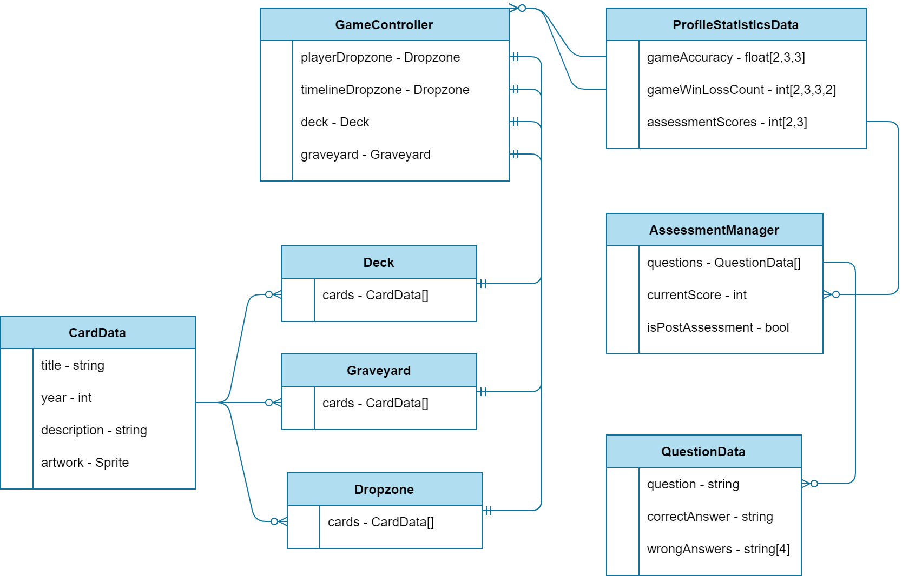

###### Figure 19: EERD of Bytes of Past

The figure above shows the entities present within the game, as well as their relationship multiplicities between each other. All the data about the student are stored in a Profile Statistics Data, which includes their win and loss counts, running average game play accuracy, and their Pre and Post Assessment Scores. The Game Controller represents the in-game class controller that holds the data about an existing game round (either in Single Player or Multiplayer mode). A game has two Drop zones, one for the Player and one as the Timeline. Other entities include the Deck, which holds the remaining cards in the game, and the Graveyard, in which all wrongly placed cards are sent.

The Assessment Manager is an entity that manages a currently ongoing Assessment Test taken by the student. It holds the questions within a topic selected by the student, as well as their score, and a boolean that tells whether the assessment exam is taken as a pre-assessment or post-assessment. The questions are in the form of a Question Data entity, which holds the question to be asked, some wrong answers, and the correct answer.

The diagram above is implemented using a Binary Formatter that serializes and deserializes the game’s data. This data is not stored in any external and/or online databases, and does not strictly follow a relational schema.

### 3.4.7 Data Dictionary

| **Field Name** | **Data Type** | **Domain** |
| --- | --- | --- |
| gameAccuracy | float[2,3,3] | A multidimensional float array that holds the average game play accuracy with:  2 Game Modes (Single Player and Multiplayer),  3 History Topics,  and 3 Difficulty Modes |
| gameWinLossCount | int[2,3,3,2] | A multidimensional int array that holds the total games won and lost with:  2 Game Modes (Single Player and Multiplayer),  3 History Topics,  3 Difficulty Modes,  and 2 outcomes (Win or Loss) |
| assessmentScores | int[2,3] | A multidimensional float array that holds the average game play accuracy with:  2 Game Modes (Pre and Post Assessment),  and 3 History Topics |

###### Table 18: ProfileStatisticsData

| **Field Name** | **Data Type** | **Domain** |
| --- | --- | --- |
| questions | QuestionData[] | An array of Question Data that holds the necessary questions with their correct answers for a selected topic. |
| currentScore | Int | The current correct answered question count. |
| isPostAssessment | Bool | States whether the test is intended as a Diagnostic or Summative task. |

###### Table 19: AssessmentManager

| **Field Name** | **Data Type** | **Domain** |
| --- | --- | --- |
| question | string | A text to be asked as a question to the student. |
| correctAnswer | string | A text representation of the correct answer to the question. |
| wrongAnswers | string[4] | An array that holds other choices available for the question. |

###### Table 20: QuestionData

| **Field Name** | **Data Type** | **Domain** |
| --- | --- | --- |
| playerDropzone | Dropzone | A Drop zone entity for the player’s cards at hand. |
| timelineDropzone | Dropzone | A Drop zone entity for the game’s timeline cards. |
| deck | Deck | A Deck entity that holds cards in the game. |
| graveyard | Graveyard | A Graveyard entity that holds discarded cards in the game. |

###### Table 21: GameController

| **Field Name** | **Data Type** | **Domain** |
| --- | --- | --- |
| cards | CardData[] | An array of Card Data that holds the remaining cards in a game. |

###### Table 22: Deck

| **Field Name** | **Data Type** | **Domain** |
| --- | --- | --- |
| cards | CardData[] | An array of Card Data that holds the wrongly played cards in a game. |

###### Table 23: Graveyard

| **Field Name** | **Data Type** | **Domain** |
| --- | --- | --- |
| cards | CardData[] | An array of Card Data that holds the correctly played cards in a game. |

###### Table 24: Dropzone

| **Field Name** | **Data Type** | **Domain** |
| --- | --- | --- |
| title | string | A text stating the name of a card’s invention. |
| year | int | A number representing the year the invention was made. |
| description | string | A short statement with key facts about the invention. |
| artwork | Sprite | An in-game resource that holds the graphical image data of the invention. |

###### Table 25: CardData

### 

### 3.4.8 Screenshots

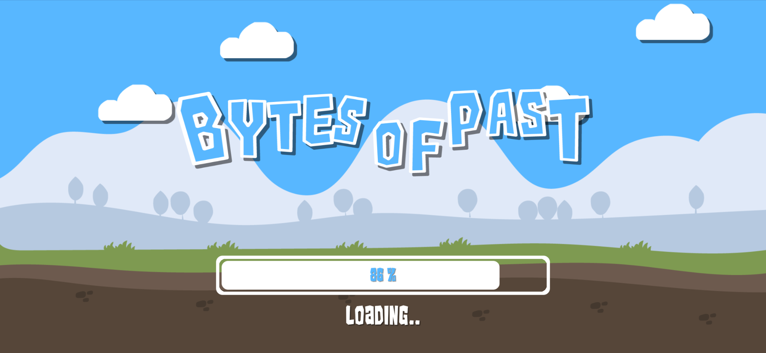

###### Figure 20: Loading Screen

The figure above shows a screenshot within the game while the game scenes and assets are loading. A loading bar with a percentage indicates the current progress of the loading of the game.

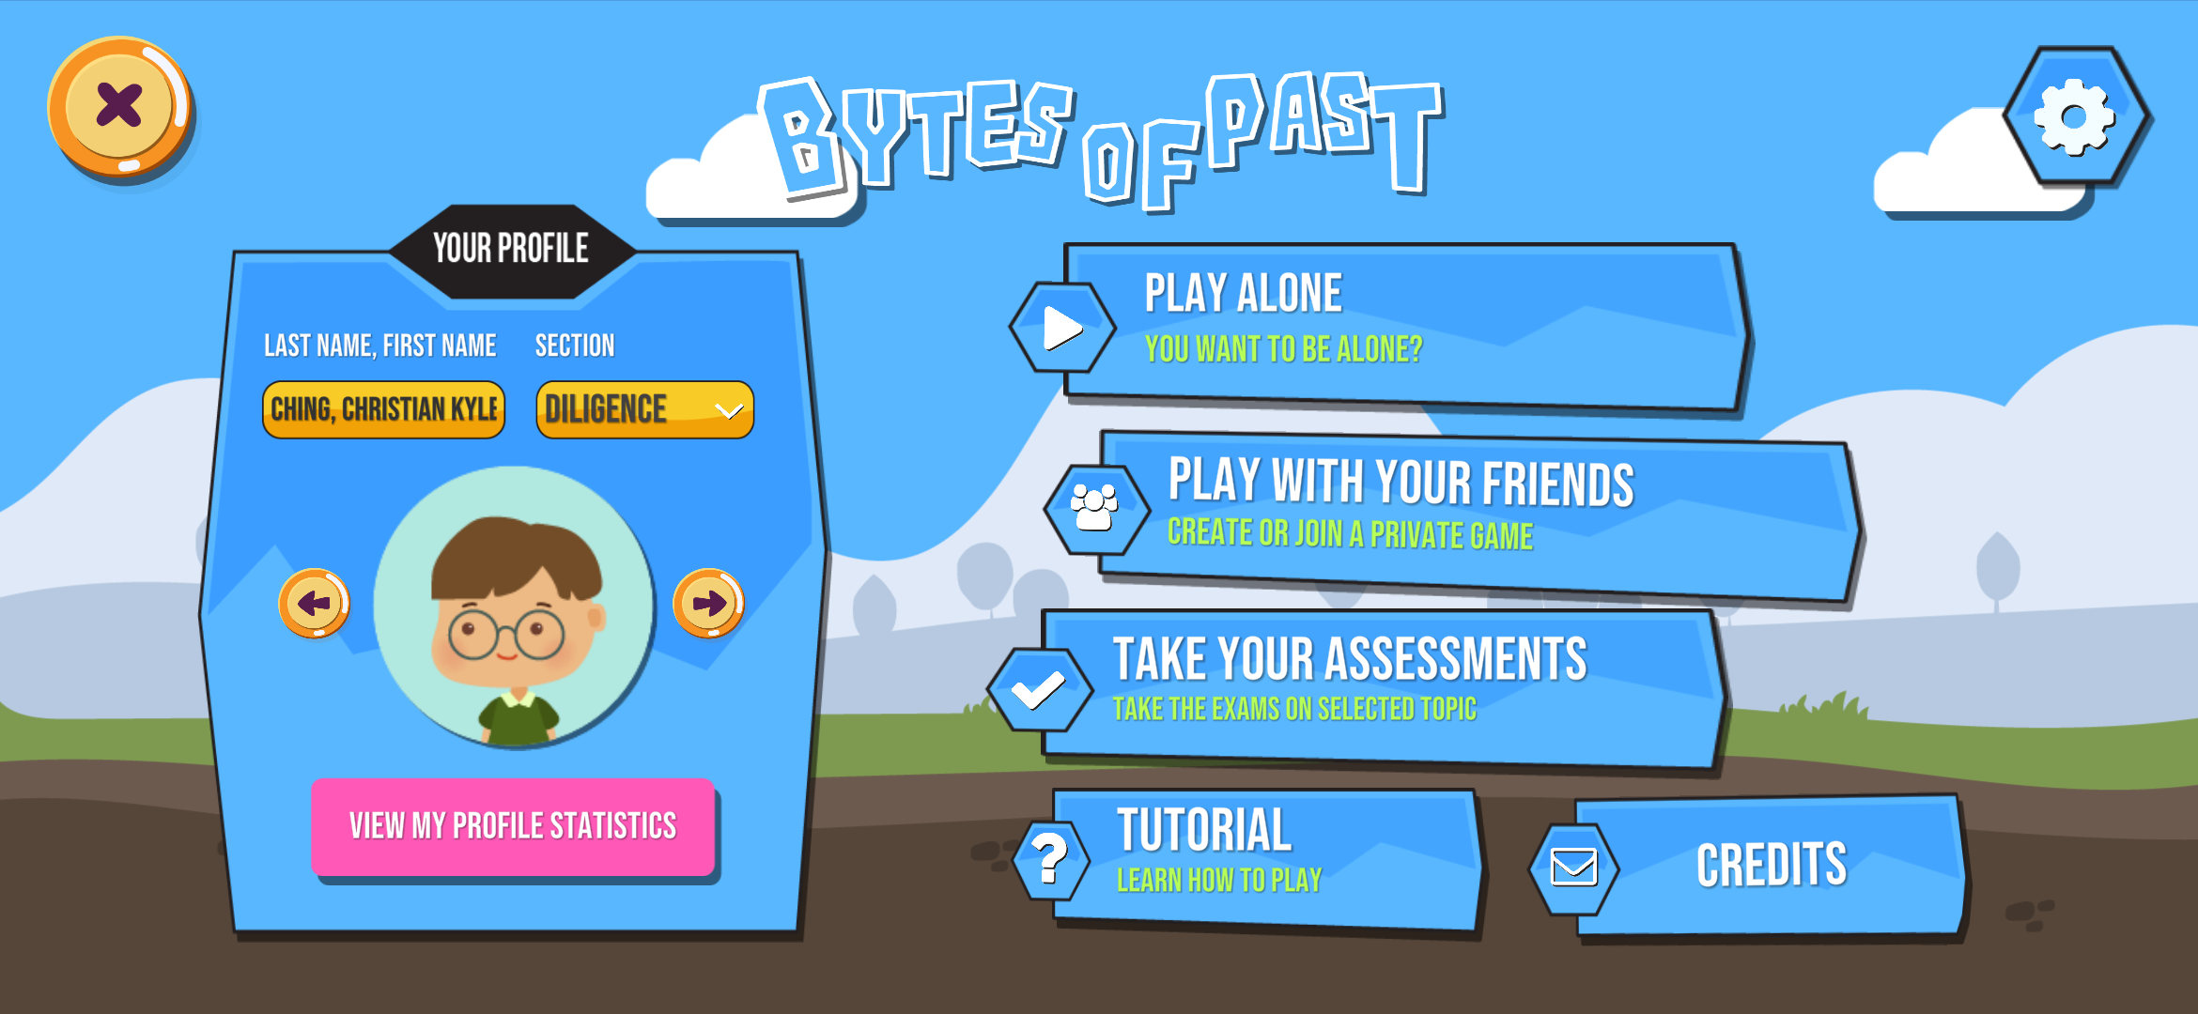

###### Figure 21: Main Menu Screen

The figure above shows the Main Menu Screen from the start of the game. Here, the player can select which game mode to take. Play Alone (Single Player) and Play with your Friends (Multiplayer) are the two game modes for the card game, while the Take your Assessment is for taking the multiple-choice quiz, as part of their teacher’s and proponent’s assessment of the effectiveness of the game in teaching the historical topics.

At the bottom of the screen, the player can also access buttons which navigate to other screens, Tutorial and the Game Settings. Tutorial section is for the player wherein they will learn how to play the entire game. Game settings, where the player can do some adjustment inside the game such as the SFX, background music volume, and the visual quality of the game.

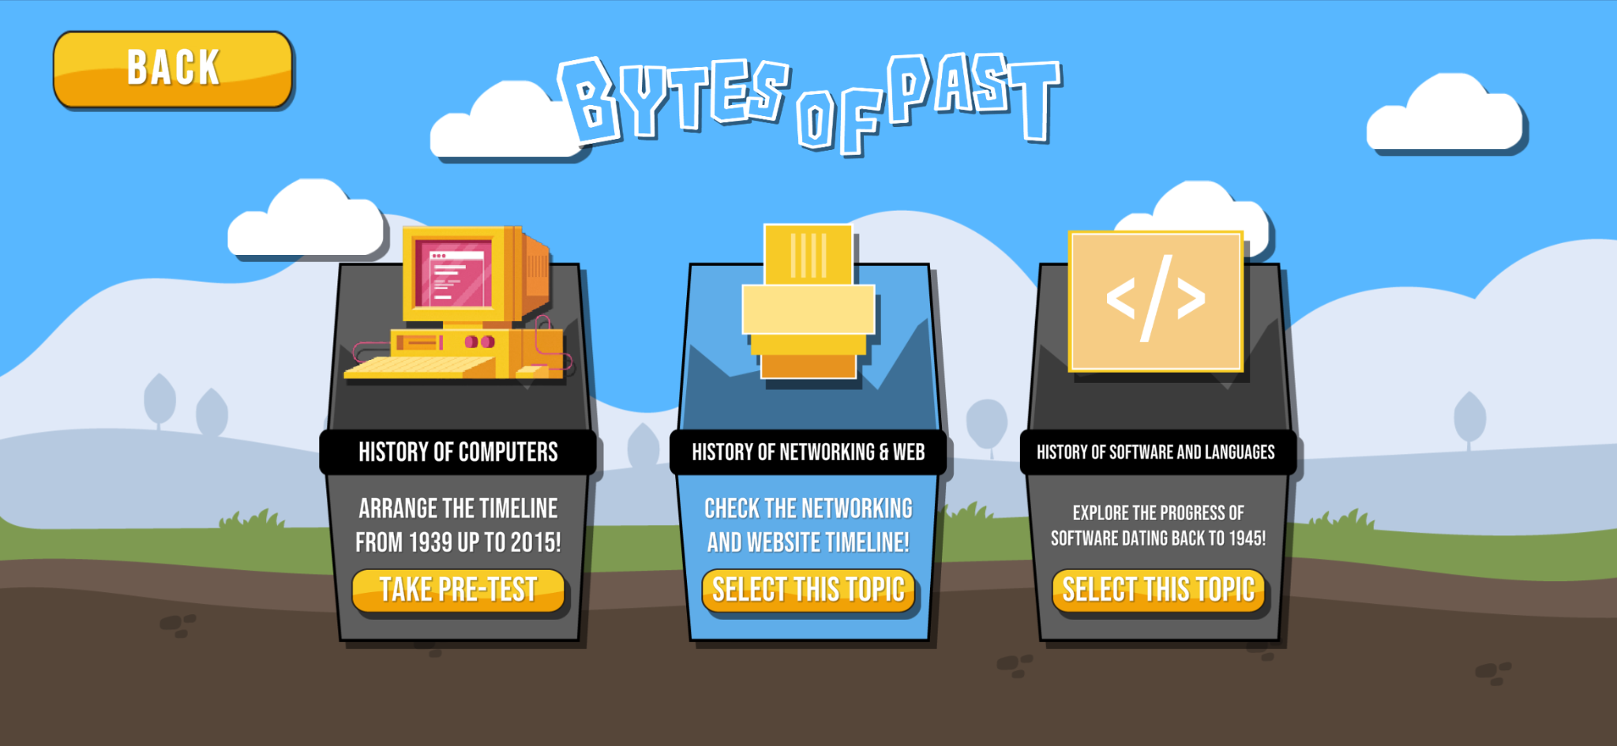

###### Figure 22: Topic Select Screen

The figure above shows the Topic Select Screen where the player can choose one topic to play. There are three (3) topics to choose; History of Computers, History of Networking and Web, and History of Software and Languages. Each of these have facts and information about the topic they will choose to play.

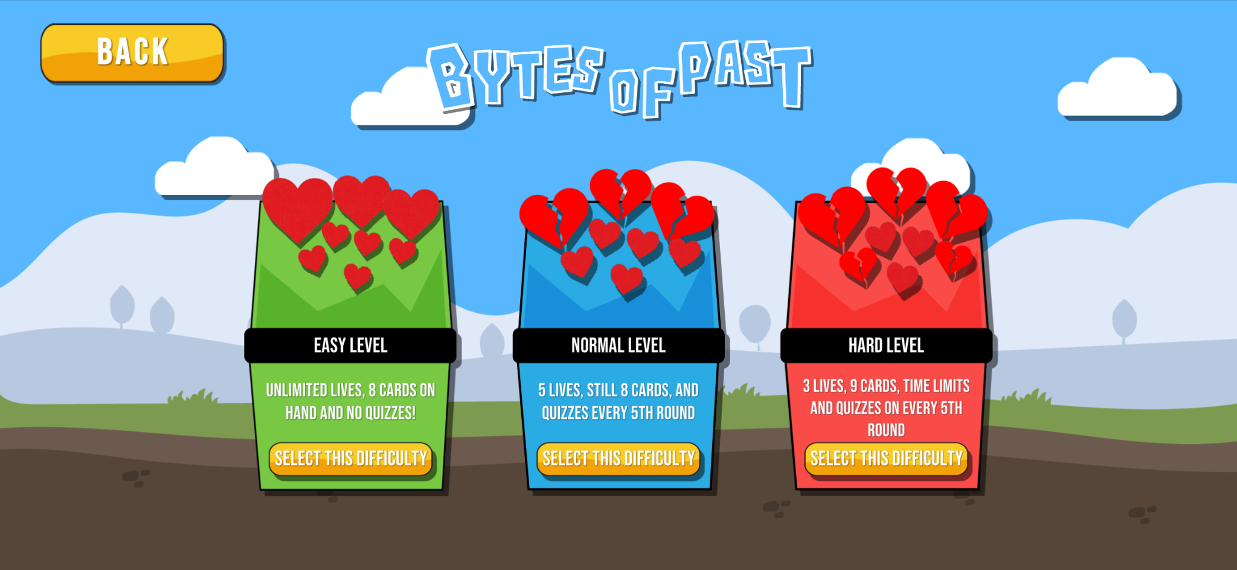

###### Figure 23: Difficulty Select Screen

The figure above shows the Difficulty Select Screen. Here, the player can choose what difficulty the card game will be. The difficulties are divided into three (3), the Easy Level, the Normal Level, and the Hard Level.

In Easy Level, the player has unlimited lives, eight (8) cards on hand and there will be no quizzes. For the Normal Level, the player has five (5) lives, eight (8) cards on hand, and there will be quizzes every 5th round. In Hard Level, the player will only have three (3) lives, additional one (1) card to make it nine (9) cards on hand, a time limit and there are still quizzes in every 5th round.

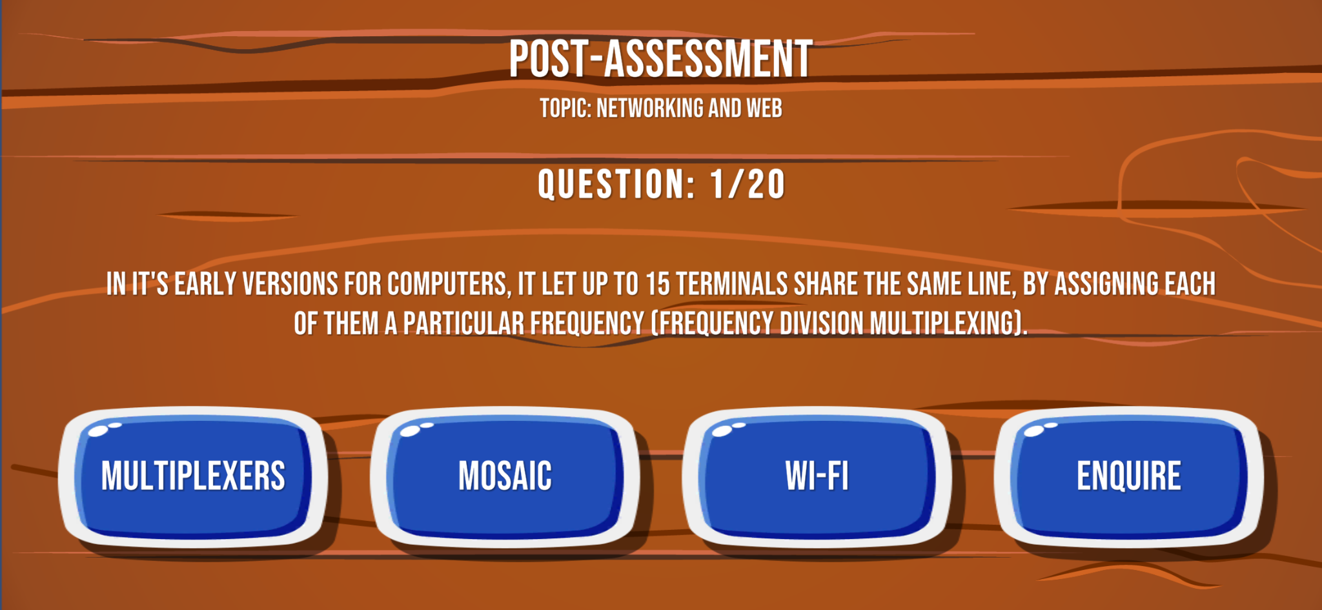

###### Figure 24: Assessment Test Screen (Pre or Post)

In the figure above, the user interface for an Assessment Test (Pre or Post) is shown. The screen shows the Assessment mode and the selected topic, as well as the current question number, the question statement and the choices. The answers are in the form similar to a multiple-choice quiz, where the student is given 4 randomized choices with only one correct answer.

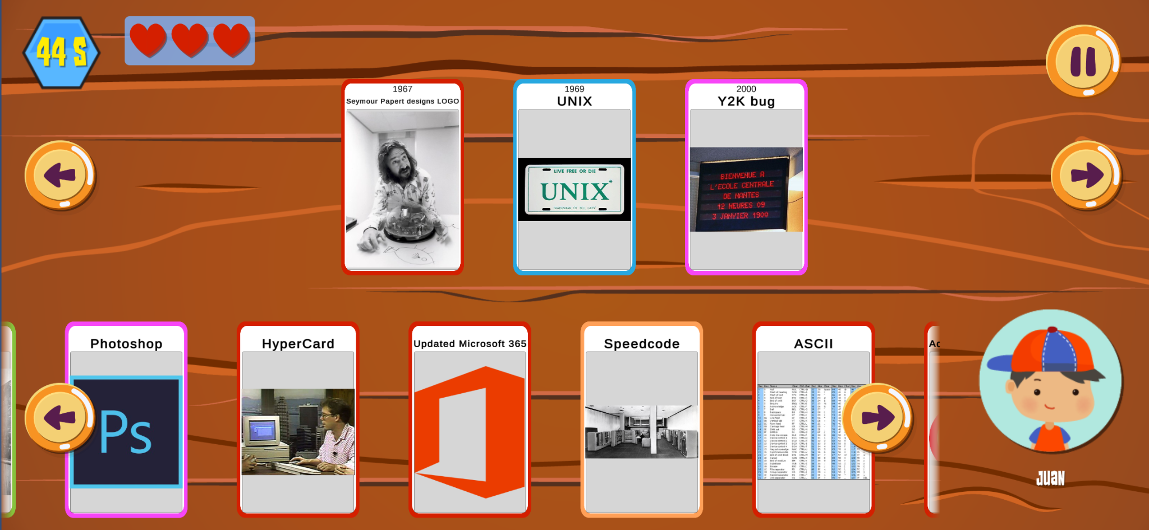

###### Figure 25: Single Player Game

The figure above shows the screen for a game in single player mode. Cards that are in the upper portion of the screen represent the played cards already in the timeline. The cards in the bottom portion shows the cards in the player’s hand. The deck is shown on the right side of the screen, along with the remaining card count in the deck. The player's remaining life is shown at the top left side of the game screen.

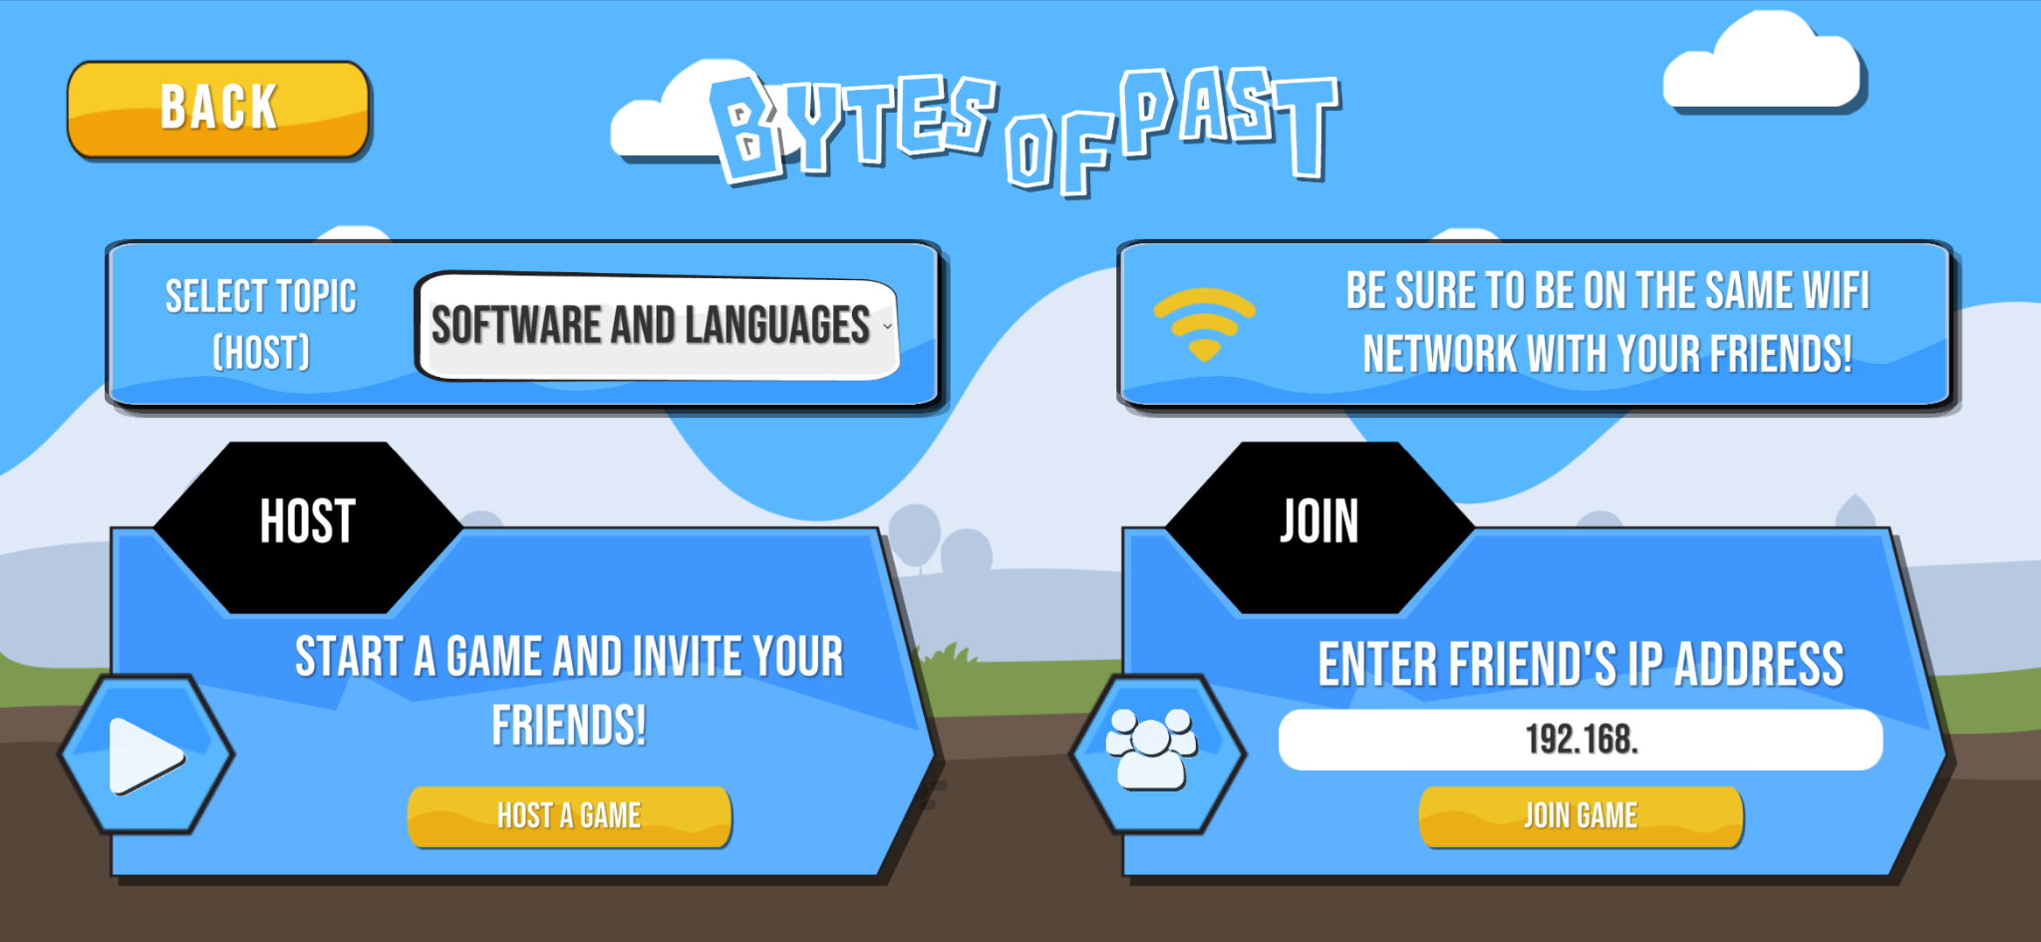

###### Figure 26: Multiplayer - Create or Join Screen

The screen above shows the two options available when playing a Multiplayer Game. The first option is to join a current game lobby where other players are waiting before starting a game. The player can join a game by asking the host for the lobby code. The other option is for the player to actually host the game, and wait for other players to join by sharing the code to other players.

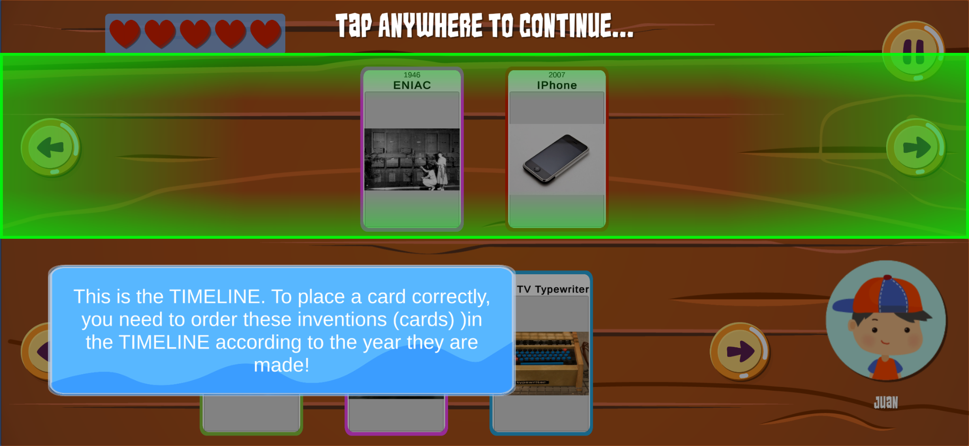

###### Figure 27: Tutorial

In the figure above, the player is given step-by-step instructions on how to play the game on its basic mechanics. The game shows the card areas, where and how to place cards, and the player lives.

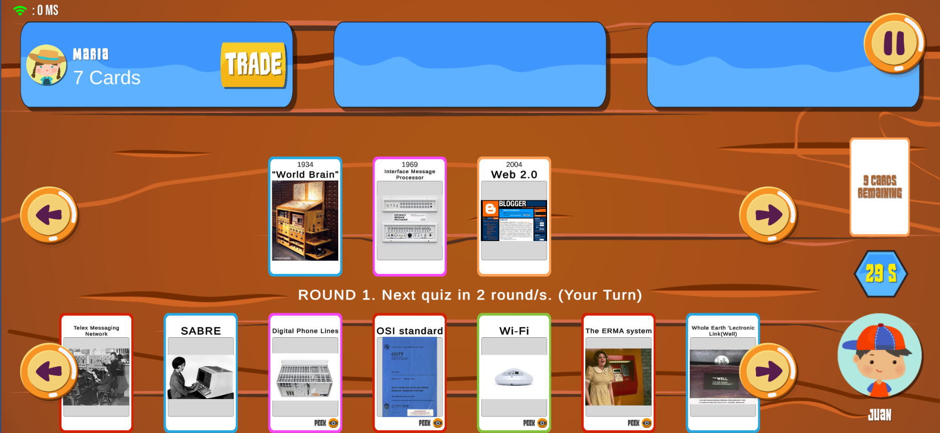

###### Figure 28: Multiplayer Game

In the figure above, the layout of the multiplayer game scene is shown. The layout is similar to the single player screen, but the top portion shows the other players in the game together with the number of cards left in their hands. The placement of player’s hand cards, the timeline, and the deck remains the same as seen in the single-player screen.

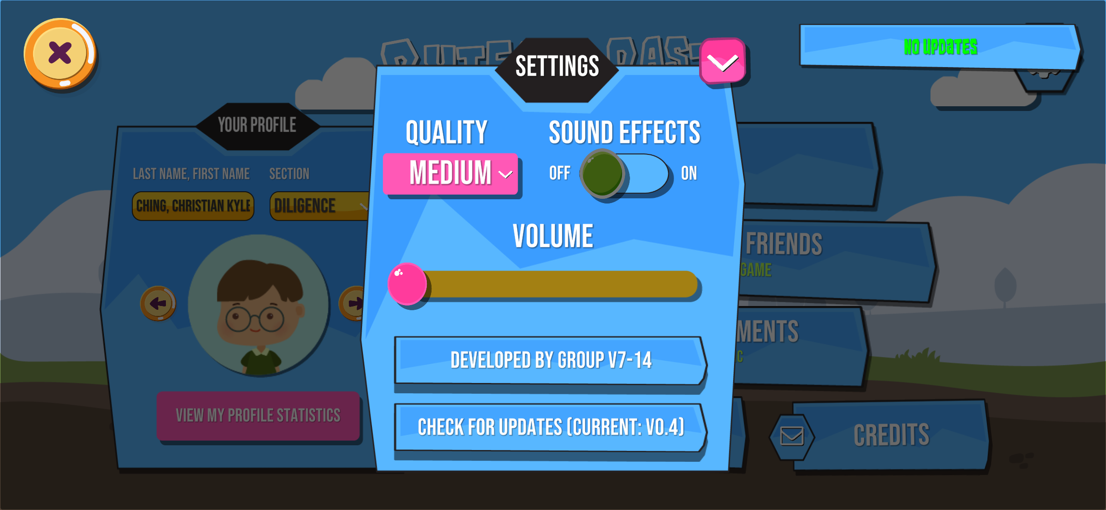

###### Figure 29: Game Settings Screen

The figure above shows the Game Settings Screen. Here, the player can adjust the volume of the music, the sound effects and the quality of the game. In the quality of the game, the player can choose between Low, Medium or High. For the sound effects, the player can decide whether to turn it on or turn it off. For the volume of music, the player can drag the slider to adjust the volume. At the bottom part of the settings, the player can view the group who develop the game.

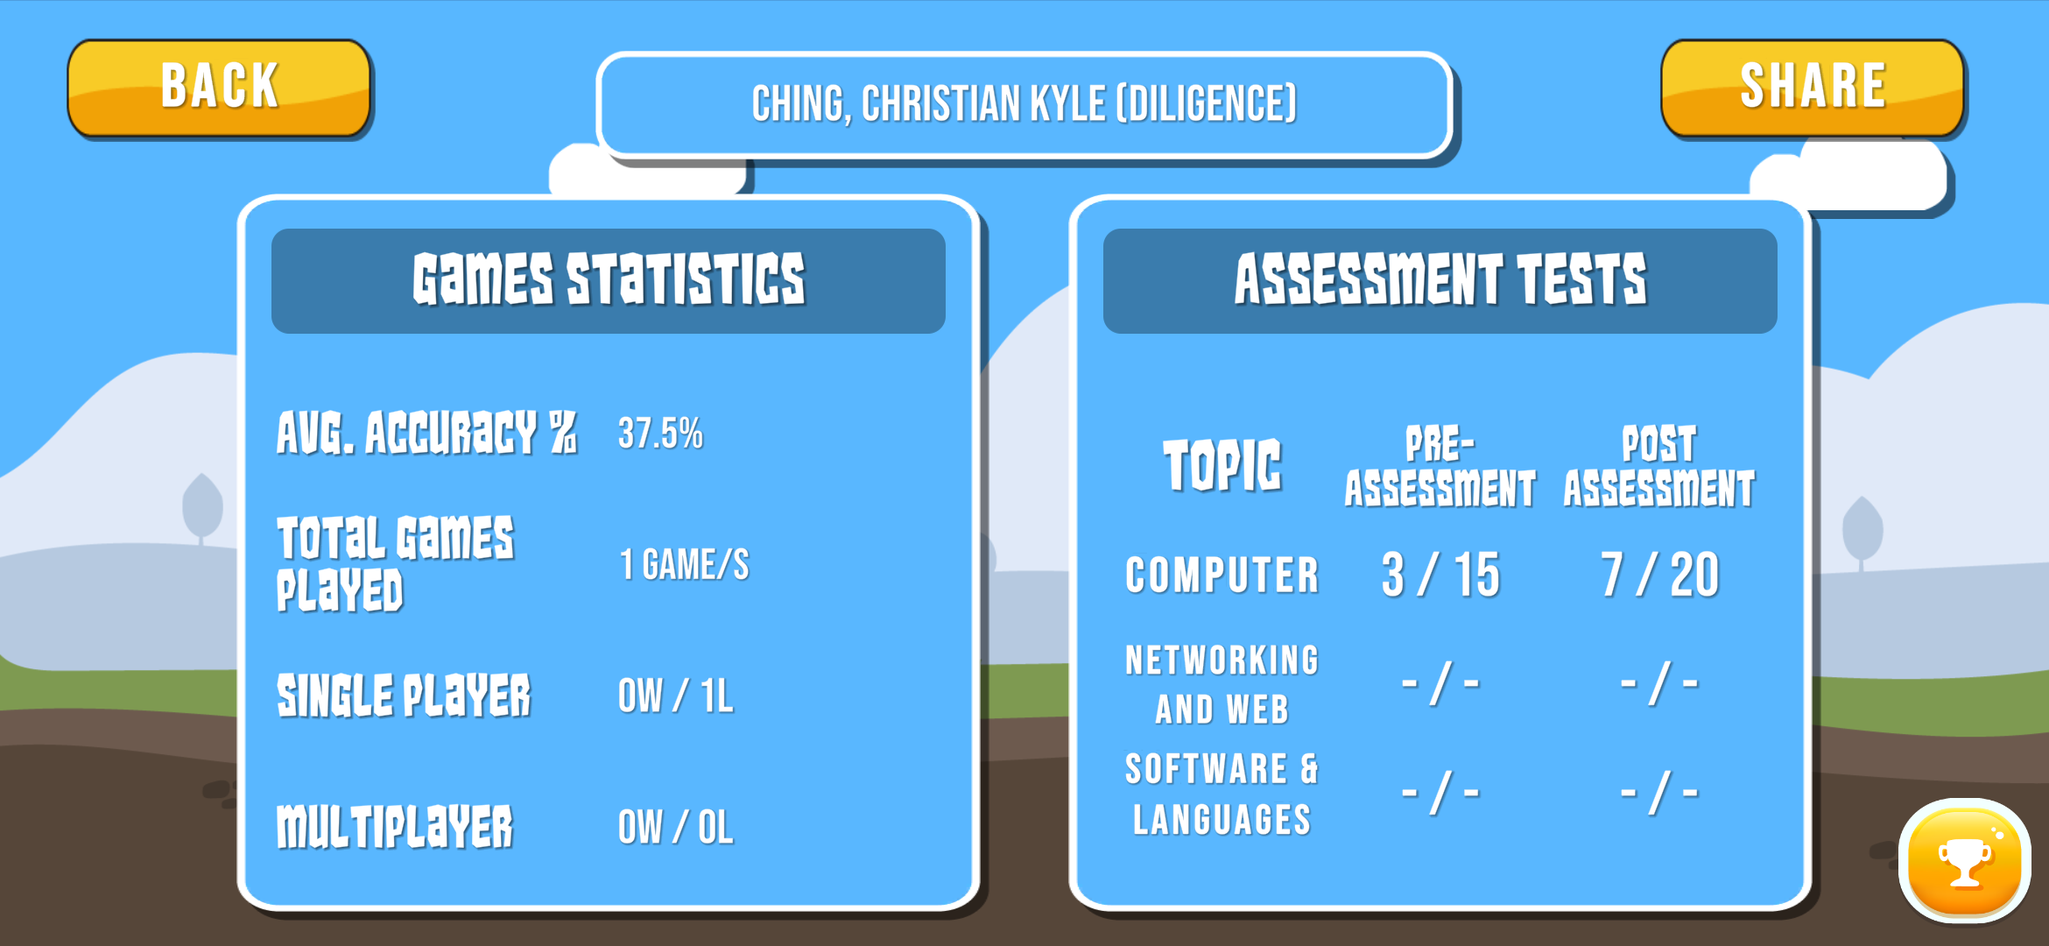

###### Figure 30: Profile Statistics Screen

The figure above shows the Profile Statistics Screen. Here, the player can view the statistics that have been achieved after playing the game.

On the left side, the Overall Statistics of the player. It shows the average accuracy of the player, how many games the player played and how many wins the player has in both single player and multiplayer matches. On the right side is the Assessments. It shows the scores that the player achieves after answering the assessment exams.

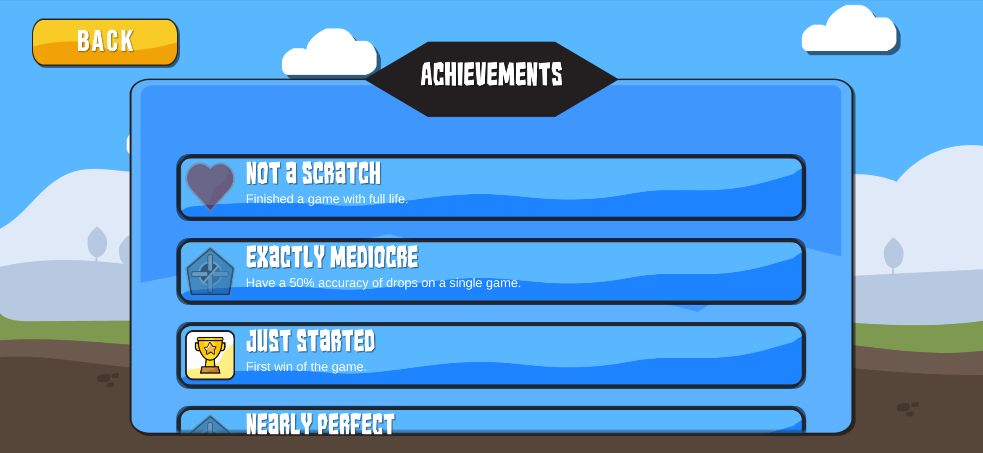

###### Figure 31: Achievements Screen

The figure above shows the Achievements screen wherein it shows the player’s achievement done while playing the game. As the player plays the game, there are different achievements unlocked such as winning the game, getting a certain percentage of accuracy as the player plays, and having excellent performance in the game. This will add some excitement for the player in playing the game.

## 3.5 Testing and Evaluation Plan

The system will undergo User Acceptance Testing (UAT) with two phases, namely Alpha and Beta Testing. This testing is done to verify if the software’s functionality aligns with what the client requires and is acceptable to be released in the class environment. Upon passing the testing, the software is deemed ready for use by the students and the instructor.

During the Alpha Test, the proponents themselves conduct System Testing on their own software. This phase verifies that the software functions the way they intended, but may not align with the client’s needs or requirements. This is mainly done before Beta Test, to ensure that there are no major problems within the software that will make the software unusable to the students.

Next, Beta Testing is conducted, where potential end-users and IT Experts that are not affiliated with the proponents conduct the testing. This phase shows possible problems in misaligned understanding of requirements of the proponents to the client. This phase focuses mainly on the functionality and its usability on the instructor’s class environment, ignoring small User Interface errors. Upon passing this test, minor bug fixes can be addressed before releasing the game.

The testing aims to verify the quality of the software produced using the ISO 25010 Standards. This set of standards include the general quality of the software by looking into six (6) key characteristics / factors: (a) Functionality, (b) Reliability, (c) Usability, (d) Efficiency, (e) Maintainability, and (f) Portability.

Functionality is a key factor that verifies the desired features are present in the system. Its subcategories include Accuracy, which is how correct the results presented are, and Suitability, which verifies the appropriateness of the software for its intended purpose.

Reliability is a factor that verifies the level of system performance in different situations. Its subcategories include Availability, which looks into how often the software is ready for use and not, and Maturity, which looks into how often the software fails during its lifecycle.

Usability is the characteristic of how easy the software can be understood and learned by its users. Its subcategories include Learnability, which takes into consideration the amount of effort the users give into learning the software, and Understandability, which aims to fit the client’s intended use of the software.

Efficiency is the characteristic that compares the amount of time required to perform a function relative to the amount of required resources to accomplish it. Its subcategories include Time Behavior, which observes the amount of time required to process a transaction meets the requirements, and Resource Utilization, which looks into the amount of required resources in order to complete an action in the system.

Maintainability checks to see if the software requires minimal effort in modifying its features. Its subcategories include Analyzability, which looks into how easy it is to identify the cause of problems within the source code, and Stability, which checks to see unexpected results of modification to the software.

Lastly, Portability, a characteristic that verifies how well the software can be modified to be used in other environments. Its subcategories include Adaptability, which looks into the ability of the software to adapt to changing situations, and installability, which aims to verify if the software is installable on the intended device and platform.

### 3.5.1 Entry Criteria

* The system should have passed integration testing through ad-hoc / exploratory testing.
* The test plan should be approved by the adviser.
* The testing environment should be ready.

### 3.5.2 Exit Criteria

* All test cases should be executed.
* No critical / high priority bugs should be left in an open state.
* For low to medium priority bugs, if left in an open state, it should be accepted by the board of panel during the final defense.

### 3.5.3 Schedule

| **Strategy** | **Activity** | **Person Involved** | **Duration** |
| --- | --- | --- | --- |
| **Alpha Test** | Preparation | Proponents | 3-4 Days |
|  | System Testing | Proponents | 2 Days |
| **Beta Test** | Writing and submission of letter to conduct beta test and evaluation | Proponents  IT Experts  Instructor (Client) | 3-5 Days |
|  | System Testing and Evaluation | IT Experts  Students (Target End Users) | 5-7 Days |

### 3.5.4 Test Cases

| **Test**  **Case**  **ID** | **Case Name** | **Description** | **Test Data** | **Actual Result** | **Passed**  **/Failed** | **Remarks** |
| --- | --- | --- | --- | --- | --- | --- |
| **001** | Change Game BGM Volume | The player is able to adjust the volume of the background music |  |  |  |  |
| **002** | Change Game SFX Volume | The player is able to adjust the volume of sound effects |  |  |  |  |
| **003** | Drop Card | The player is able to place or drop cards on the timeline |  |  |  |  |
| **004** | Setup Profile Name | The player can input their name |  |  |  |  |
| **005** | Setup Profile Section | The player can input their class section |  |  |  |  |
| **006** | View Profile | The player can be able to view information about himself/herself |  |  |  |  |
| **007** | Choose Mode | The player can select what mode he/she wants to play: Single Player Mode or Multiplayer Mode |  |  |  |  |
| **008** | Create a Lobby | The player has an ability to create a lobby where he/she can invite his/her friends to play the game |  |  |  |  |
| **009** | Choose ICT Topic | The player has an ability to pick one topic he wants to be the theme of the card game he will play and the theme of the exam he/she will answer.. |  |  |  |  |
| **010** | Choose Difficulty | The player is able to select between, easy, normal, hard difficulty before the start of the game |  |  |  |  |
| **011** | Draw Card From Deck | The player can draw card from the deck |  |  |  |  |
| **012** | Use Special Action Cards | The player has a chance to get a special action card and use it to his/her advantage to the other players |  |  |  |  |
| **013** | Trade Card | The player has a chance to trade his/her card to the player of his/her choice. |  |  |  |  |
| **014** | View Player Game Statistics | The player are able to see the statistics he/she have such as match history |  |  |  |  |
| **015** | View Achievements | The player is able to view the achievements he accomplish while playing the game |  |  |  |  |
| **016** | Take Assessment Tests/Exam | The player can answer assessment exams before and after playing the game |  |  |  |  |
| **017** | View Questions | The player can view the questions in the assessment exam |  |  |  |  |
| **018** | Answer Question | The player needs to answer the question in assessment exam |  |  |  |  |
| **019** | Validate Answer | The player can check if he/she answer the questions correctly |  |  |  |  |
| **020** | View Assessment Score | The player can access or view their scores after answering the assessment exam |  |  |  |  |

### 3.5.5 Evaluation Tool

| **RATING** | **DESCRIPTION** |
| --- | --- |
| 5 | Strongly Agree |
| 4 | Agree |
| 3 | Undecided |
| 2 | Disagree |
| 1 | Strongly Disagree |

| **INDICATORS** | **5** | **4** | **3** | **2** | **1** |
| --- | --- | --- | --- | --- | --- |
| **FUNCTIONALITY** | | | | | |
| **Accuracy**  The system is accurate and performs its function correctly.  The system is capable of providing the correct outcome/result to its user. |  |  |  |  |  |
| **Suitability**  The system is suitable or appropriate for the needs of the client.  The system has the presence and appropriateness of a set of functions for specified tasks. |  |  |  |  |  |
| **RELIABILITY** | | | | | |
| **Availability**  The system is being able to be used.  The system is fully functioned and able to be used by the end user. |  |  |  |  |  |
| **Maturity**  The system is matured enough to use.  The system measures attributes that allow it to conclude about the frequency of failure by faults inside the system. |  |  |  |  |  |
| **USABILITY** | | | | | |
| **Learnability**  The system is easy to learn by the users.  The system provides instructions and simple interfaces so that the user may quickly learn how to use the system. |  |  |  |  |  |
| **Understandability**  The system is easy to comprehend by the users, especially its functions and the system applicability.  The system provides a consistent interface and consistent use of terms throughout the system that is easy to understand by the user. |  |  |  |  |  |
| **EFFICIENCY** | | | | | |
| **Time Behaviour**  The system has the ability to respond and process the function of the system.  The system provides appropriate response time when performing certain functions. |  |  |  |  |  |
| **Resource Utilization**  The system utilizes the resources efficiently.  The system assesses how efficiently resources are used in relation to their availability. |  |  |  |  |  |
| **MAINTAINABILITY** | | | | | |
| **Stability**  The system is capable of handling the risk of the unexpected effect of modifications.  The system continues to function after the modifications have been made. |  |  |  |  |  |
| **Analysability**  The system is easy to analyze.  The system is easy to diagnose the causes of failures and identification of parts to be modified. |  |  |  |  |  |
| **PORTABILITY** | | | | | |
| **Installability**  The system is easy to install and use.  The system can be installed without much action and instructions. |  |  |  |  |  |
| **Adaptability**  This system can adapt to other environments without having to perform and apply any actions.  The system adapts to the various environments easily. |  |  |  |  |  |

### 3.5.6 Data Categorization

To answer of the IT Experts and End-Users on the level of user acceptability of Bytes of Past will be classified with the use of the following range of weighted mean and interpretation:

| **Range of Weighted Mean** | **Interpretation** |
| --- | --- |
| 4.51 - 5.00 | Strongly Agree |
| 3.51 - 4.50 | Agree |
| 2.51 - 3.50 | Undecided |
| 1.51 - 2.50 | Disagree |
| 1.50 and below | Strongly Disagree |

# CHAPTER 4

## 4.1 Results

### 4.1.1 Evaluation for IT Experts

| **Criteria** | | **Average** | **Equivalent** |
| --- | --- | --- | --- |
| **FUNCTIONALITY** | Accuracy | 4.00 | Acceptable |
| Suitability | 3.80 | Acceptable |
| **RELIABILITY** | Availability | 4.20 | Acceptable |
| Maturity | 4.00 | Acceptable |
| **USABILITY** | Learnability | 4.20 | Acceptable |
| Understandability | 4.20 | Acceptable |
| **EFFICIENCY** | Time Behaviour | 3.40 | Undecided |
| Resource Utilization | 4.00 | Acceptable |
| **MAINTAINABILITY** | Stability | 4.20 | Acceptable |
| Analysability | 4.00 | Acceptable |
| **PORTABILITY** | Installability | 3.60 | Acceptable |
| Adaptability | 3.40 | Undecided |
| **TOTAL MEAN** | | **3.92** | **Acceptable** |

###### Table 26: Evaluation Results of IT Experts

Therefore, the overall mean of the IT Expert acceptability is 3.92, which means that the Mean for IT Expert is Acceptable.

### 4.1.2 Evaluation for End Users

| **Criteria** | | **Average** | **Equivalent** |
| --- | --- | --- | --- |
| **FUNCTIONALITY** | Accuracy | 4.60 | Highly Acceptable |
| Suitability | 4.57 | Highly Acceptable |
| **RELIABILITY** | Availability | 4.60 | Highly Acceptable |
| Maturity | 4.50 | Acceptable |
| **USABILITY** | Learnability | 4.67 | Highly Acceptable |
| Understandability | 4.67 | Highly Acceptable |
| **EFFICIENCY** | Time Behaviour | 4.50 | Acceptable |
| Resource Utilization | 4.53 | Highly Acceptable |
| **MAINTAINABILITY** | Stability | 4.50 | Acceptable |
| Analysability | 4.40 | Acceptable |
| **PORTABILITY** | Installability | 4.67 | Highly Acceptable |
| Adaptability | 4.67 | Highly Acceptable |
| **TOTAL MEAN** | | **4.57** | **Highly Acceptable** |

###### Table 27: Evaluation Results of End Users

Therefore, the overall mean of the IT Expert acceptability is 4.57, which means that the Mean for End Users is Highly Acceptable.

## 4.2 Summary of Findings

### 4.2.1 Accuracy

According to the evaluation results of the IT experts for Accuracy, the system is accurate and performs its function correctly is Acceptable.

While for the evaluation results of the end users for Accuracy, the system is capable of providing the correct outcome/result to its user is Highly Acceptable.

### 4.2.2 Suitability

According to the evaluation results of the IT experts for Suitability, the system is suitable or appropriate for the needs of the client is Acceptable.

While for the evaluation results of the end users for Suitability, the system has the presence and appropriateness of a set of functions for specific tasks is Highly Acceptable.

### 4.2.3 Availability

According to the evaluation results of the IT experts for Availability, the system is being able to be used is Acceptable.

While for the evaluation results of the end users for Availability, the system is fully functioned and able to be used by the end user is Highly Acceptable.

### 4.2.4 Maturity

According to the evaluation results of the IT experts for Maturity, the system is matured enough to use is Acceptable.

While for the evaluation results of the end users for Maturity, the system measures attributes that allows it to conclude that the frequency of failure by faults inside the system is Acceptable.

### 4.2.5 Learnability

According to the evaluation results of the IT experts for Learnability, the system is easy to learn by the users and is Acceptable.

While for the evaluation results of the end users for Learnability, the system provides instructions and simple interfaces so that the user may quickly learn how to use the system is Highly Acceptable.

### 4.2.6 Understandability

According to the evaluation results of the IT experts for Understandability, the system is easy to comprehend by the users, especially its functions and the system applicability is Acceptable.

While for the evaluation results of the end users for Understandability, the system provides a consistent interface and consistent use of terms throughout the system that is easy to understand by the user and is Highly Acceptable.

### 4.2.7 Time Behaviour

According to the evaluation results of the IT experts for Time Behaviour, the system has the ability to respond and process the function of the system is Undecided.

While for the evaluation results of the end users for Time Behaviour, the system provides appropriate response time when performing certain functions is Acceptable.

### 4.2.8 Resource Utilization

According to the evaluation results of the IT experts for Resource Utilization, the system utilizes the resources efficiently is Acceptable.

While for the evaluation results of the end users for Resource Utilization, the system assesses how efficiently resources are used in relation to their availability is Highly Acceptable.

### 4.2.9 Stability

According to the evaluation results of the IT experts for Stability, the system is capable of handling the risk of the unexpected effect of modifications is Acceptable.

While for the evaluation results of the end users for Stability, the system continues to function after the modifications have been made is Acceptable.

### 4.2.10 Analysability

According to the evaluation results of the IT experts for Analysability, the system is easy to analyze and is Acceptable.

While for the evaluation results of the end users for Analysability, the system is easy to diagnose the causes of failures and identification of parts to be modified is Acceptable.

### 4.2.11 Installability

According to the evaluation results of the IT experts for Installability, the system is easy to install and use is Acceptable.

While for the evaluation results of the end users for Installability, the system can be installed without much action and instructions is Highly Acceptable.

### 4.2.12 Adaptability

According to the evaluation results of the IT experts for Adaptability, the system can adapt to other environments without having to perform and apply any actions is Undecided.

While for the evaluation results of the end users for Adaptability, the system adapts to the various environments easily is Highly Acceptable.

# CHAPTER 5

SUMMARY OF FINDINGS

## 5.1 Conclusions

With the results gathered from the conducted data gathering of the end users (the students) and the experts in the Information Technology field, the proponents have concluded that the project has achieved an acceptable result for the project’s intended purpose and objectives.

The proponents concluded that the project achieved to create a two-dimensional (2D) mobile game for Android that showed facts about inventions about the three history topics related to ICT. The data shows that the system is acceptable at its accuracy and suitability of information, which is gathered through a single reputable source, Computer History Museum. Moreover, the data also conclude to an acceptable result of the game’s installability and adaptability in offline (Single Player) and LAN (Multiplayer) network environments.

The shedding-type card game mechanics, chronological based gameplay logic, and the different player interaction patterns in both Single Player and Multiplayer modes are proven to be acceptable by the criteria achieved in the ISO 25010 standard. The game passed the Availability and Maturity criteria as the end users are able to play the game without major errors that hinder it to function properly, especially in the multiplayer scenario. The Learnability and Understandability criteria are achieved by the game’s implementation of tutorial game modes that walk the user through the core gameplay mechanics. Time Behaviour and Resource Utilization has achieved an acceptable remark, since all the assets used for the cards (inventions) are stored within its local game files, packaged within the installer, and the LAN network gameplay proves to have lower latency since all the devices are connected physically closer to each other. Lastly, the game is also able to store profile statistics accurately, with win and loss counters, average accuracy of drops, and storing of Pre and Post Assessment tests.

Furthermore, the project was able to be installed without much hindrance because the user only needs to download and install a single file, distributed on an established website with the download button easily accessible for the users. This download button directly downloads the installer file (APK), which can then be installed in a few clicks. This method passed the Installability and Adaptability criteria of the ISO 25010 standard.

## 5.2 Recommendations

With the evaluation done by IT Experts and the End Users of the project, the proponents have gathered enough data and information for the following key recommendations for future proponents of similar systems that are not included within the scope and limitations of this project.

For the future proponents, the project can be expanded to support the iOS platform for iPhone devices. The project’s scope is limited to Android only as most of the students only have access to Android mobile phones. Future proponents can develop and deploy their game on the Play Store for Android and App Store for iOS. Additionally, cross-platform support can also be achieved when the game is published also on PC desktops.

This project also aims to be utilized in a class setting, where an instructor guides the student in playing the game, and using it to provide an engaging activity all while learning the topic at hand. These are the factors that the proponents led to decide that: the player’s statistics is stored locally on the device, and the multiplayer feature only works on a LAN network environment. However, future proponents may expand this idea further by adding support for over the Internet multiplayer gameplay, as well as establishing a dedicated game server to store and handle the data of all players, giving them login information and the possibility to sync their game progress across multiple devices.

# REFERENCES

Bado, N. (2019). Game-based learning pedagogy: a review of the literature, Interactive Learning Environments.

Caballero, J. (2000). The Effect of E-Learning on the Skills and Attitudes of Students. TIP Research Journal Manila, 5(1).

Chapman, A. (2018). Digital Games As History: how videogames represent the past and offer access to historical practice. ROUTLEDGE.

Codito Development Inc. (2017). A Brief History of the World (Version 1.5) [Mobile app]. App Store. https://apps.apple.com/us/app/a-brief-history-of-the-world/id490152130

Gutierrez, A. F. (2014). Development and Effectiveness of an Educational Card Game as Supplementary Material in Understanding Selected Topics in Biology. CBE—Life Sciences Education, 13(1), 76–82. https://doi.org/10.1187/cbe.13-05-0093

Kapp, K. (2012). The Gamification of Learning and Instruction: Game-Based Methods and Strategies for Training and Education. Pfeiffer & Company.

Mattel163 Limited. (2021). UNO!™ (Version 1.7.386) [Mobile app]. Google Play Store. https://play.google.com/store/apps/details?id=com.matteljv.uno

Parlett, D. (2013). Card game. https://www.britannica.com/topic/card-game.

Stephane Legrand (2012). Timeline for iPad (Version 1.0.0) [Mobile app]. App Store.

Su, T., Cheng, M.-T., & Lin, S.-H. (2014). Investigating the Effectiveness of an Educational Card Game for Learning How Human Immunology Is Regulated. CBE—Life Sciences Education, 13(3), 504–515. doi:10.1187/cbe.13-10-0197

# APPENDIX

## Excerpts from Curriculum

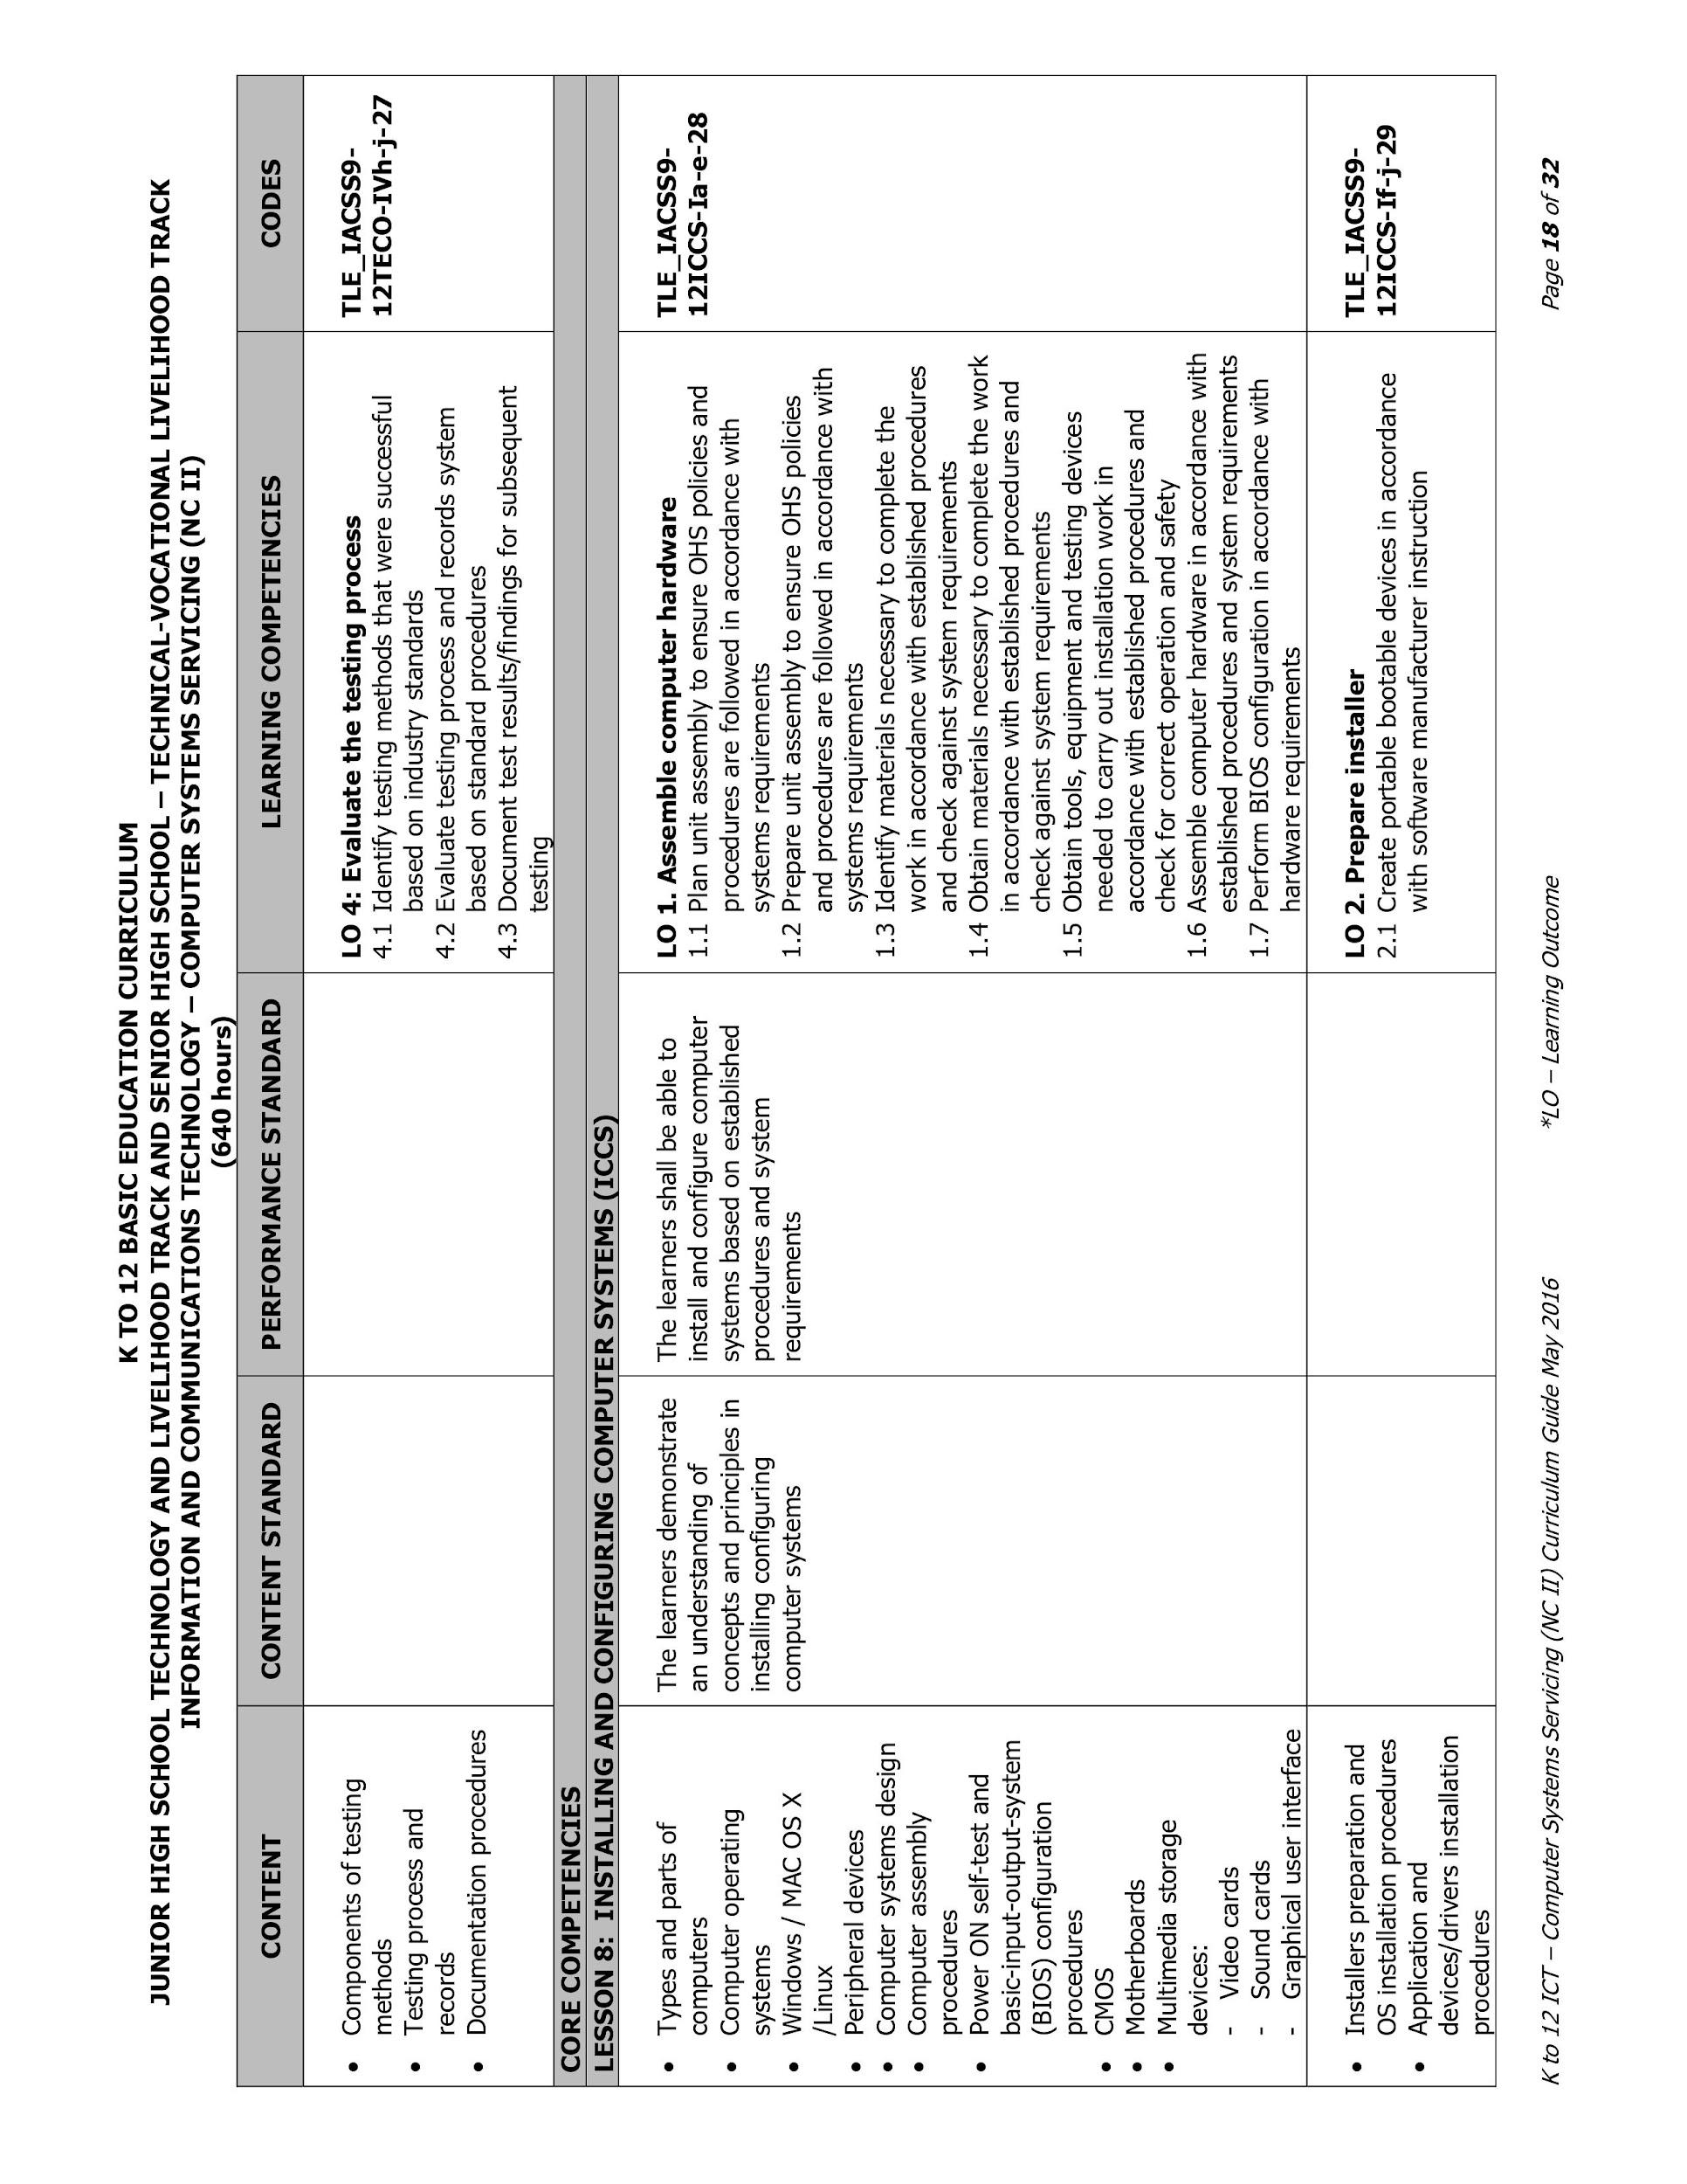

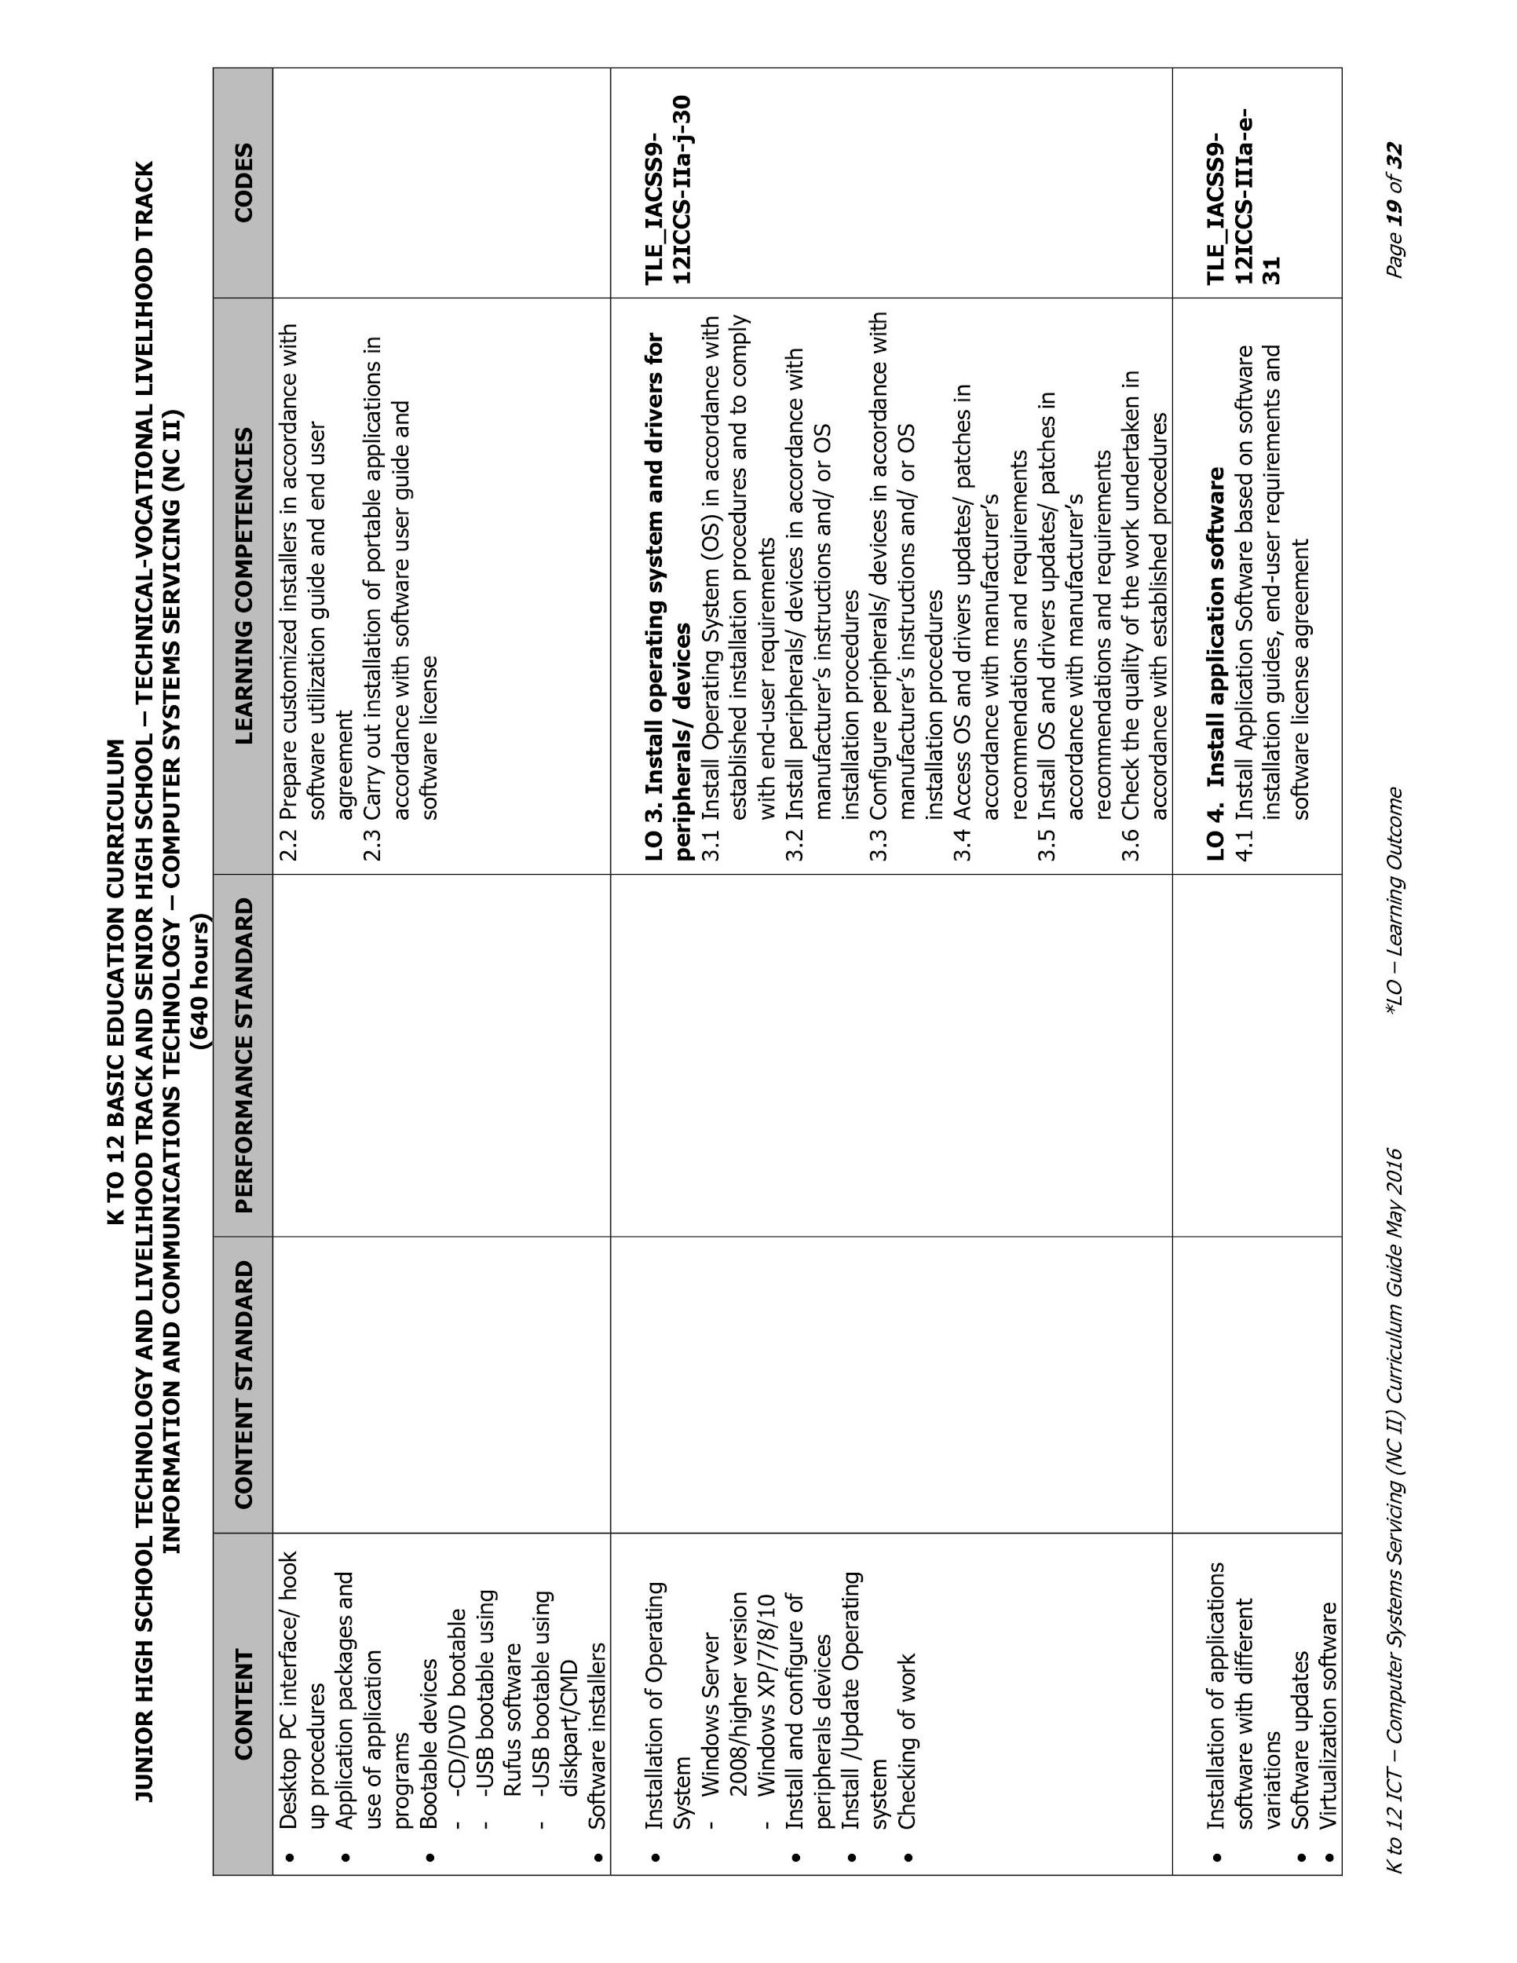

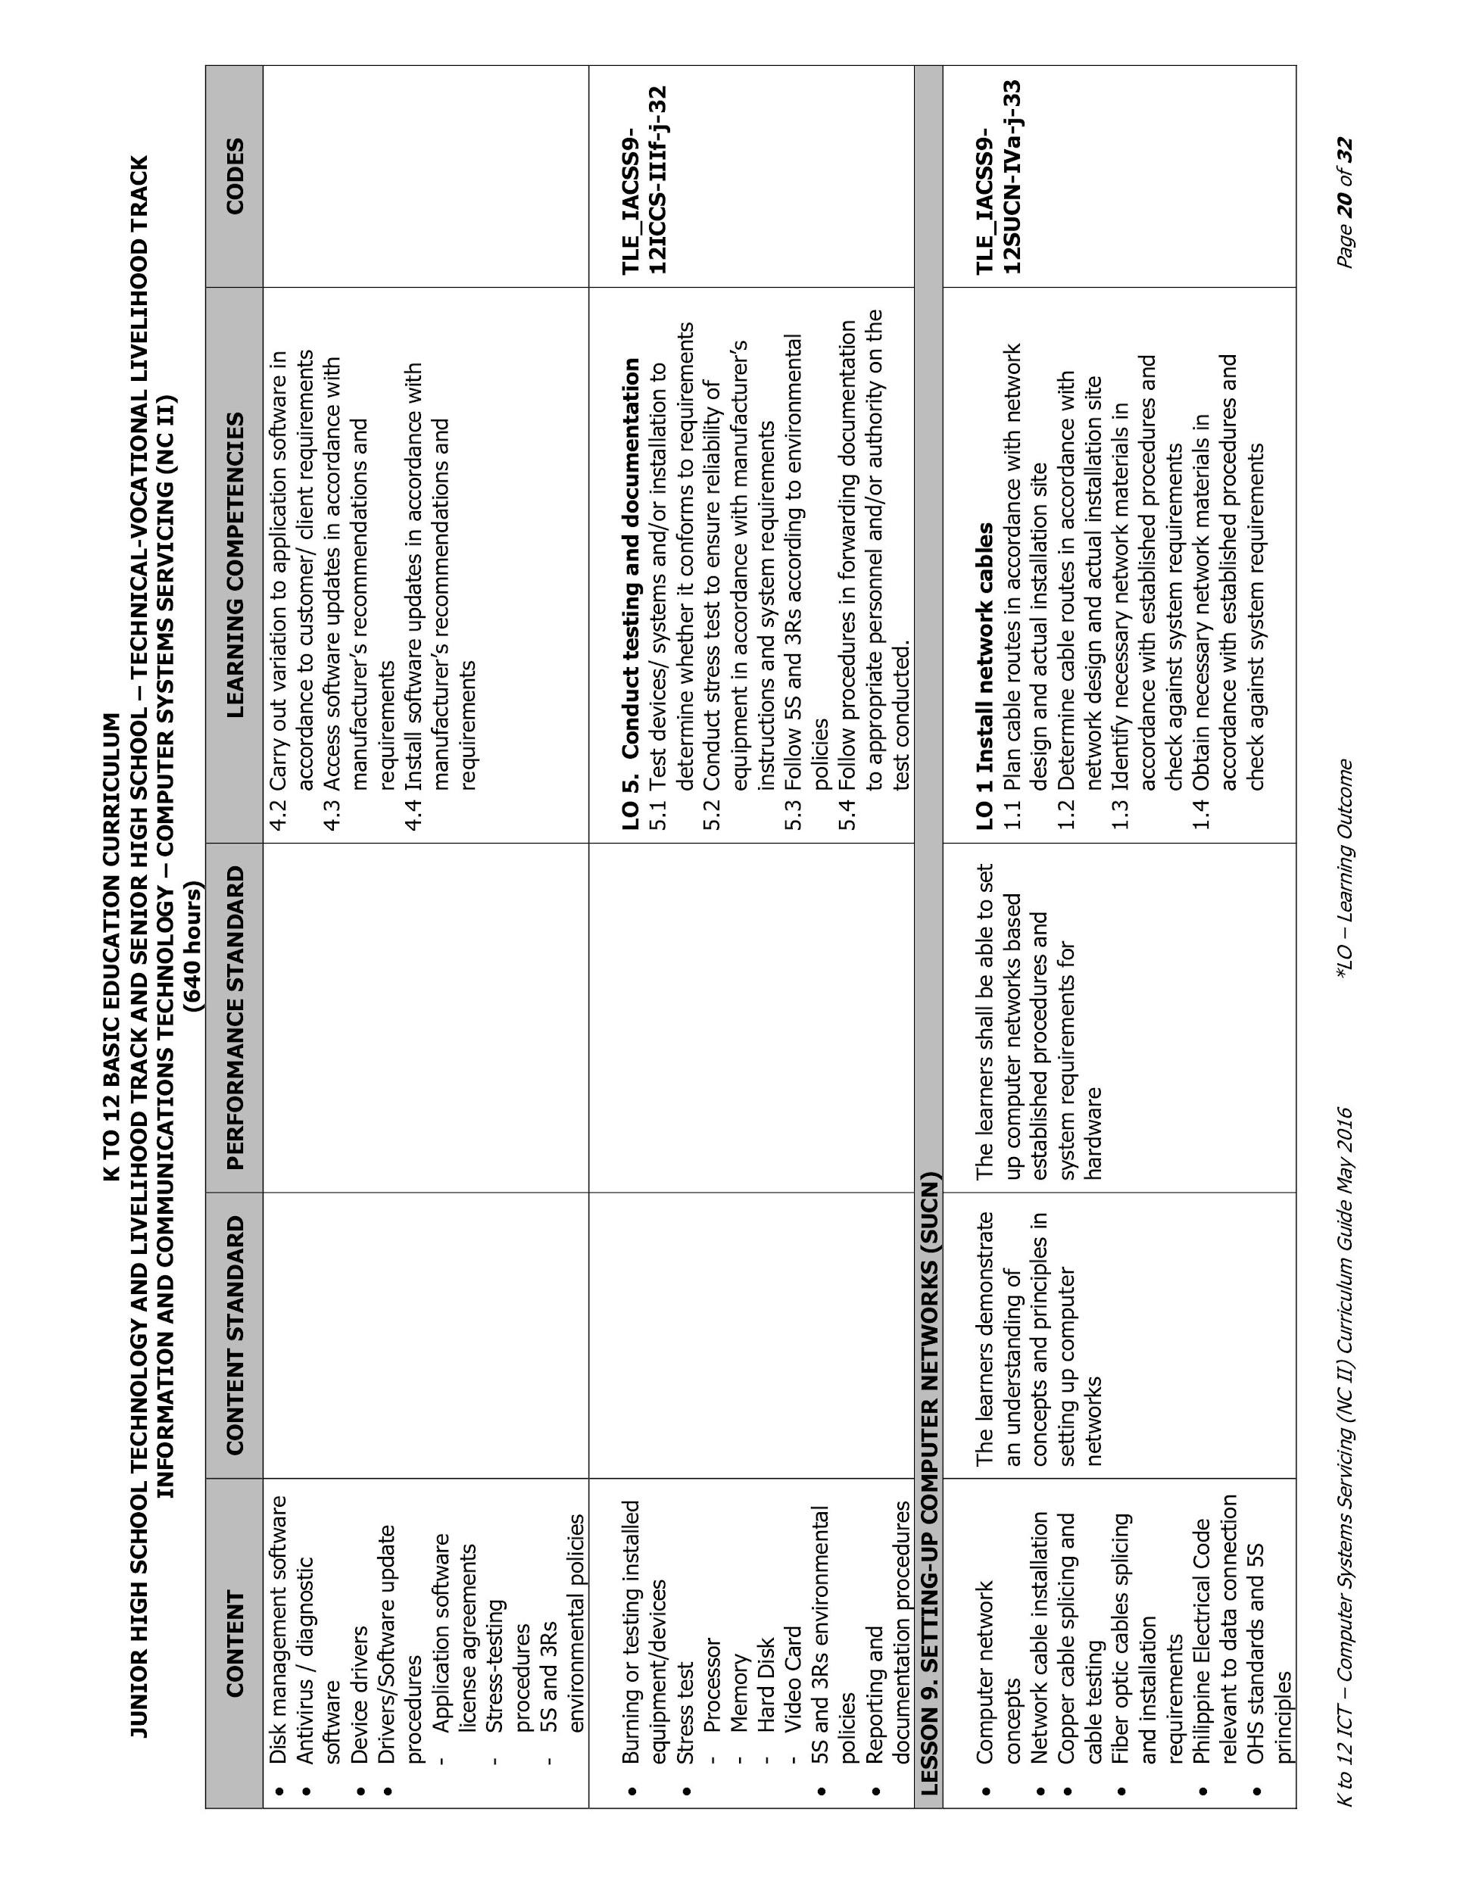

## Computer History Museum’s License to Use

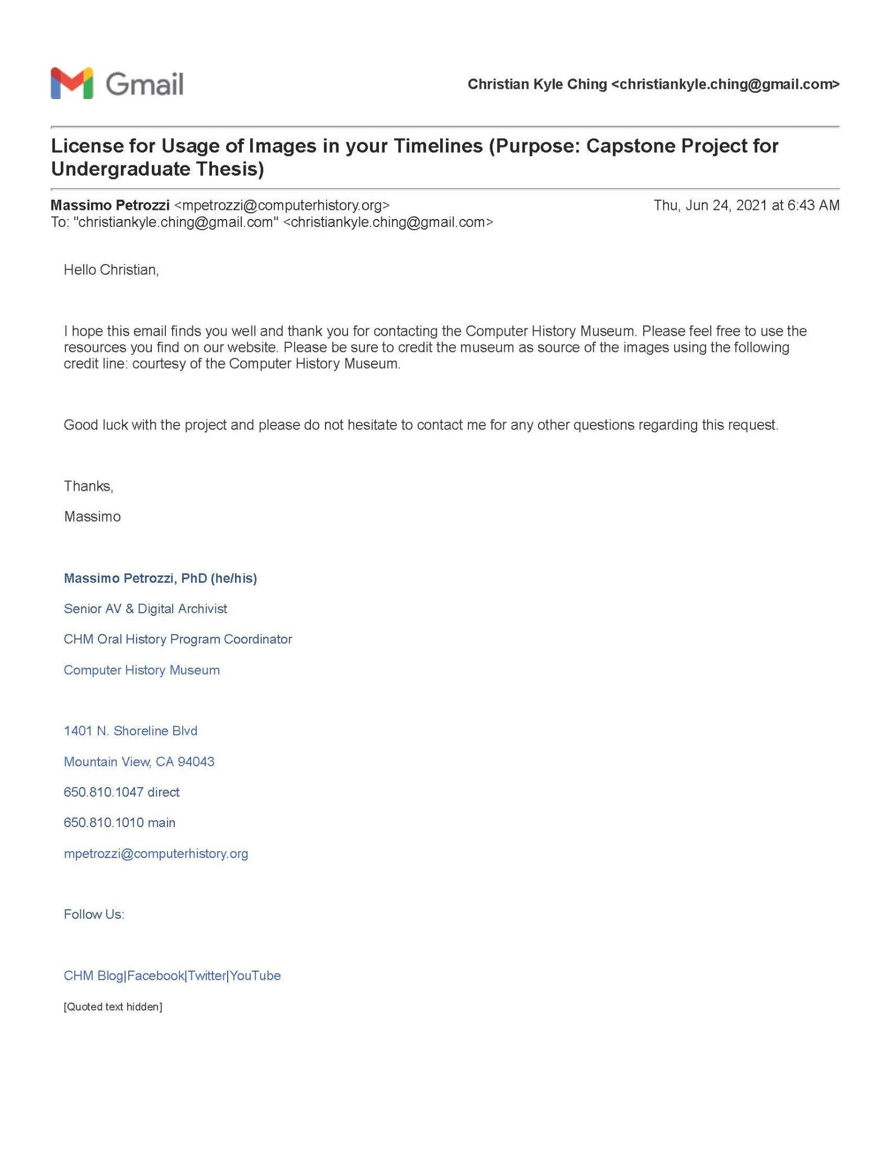

## Data Gathering Results

### End Users

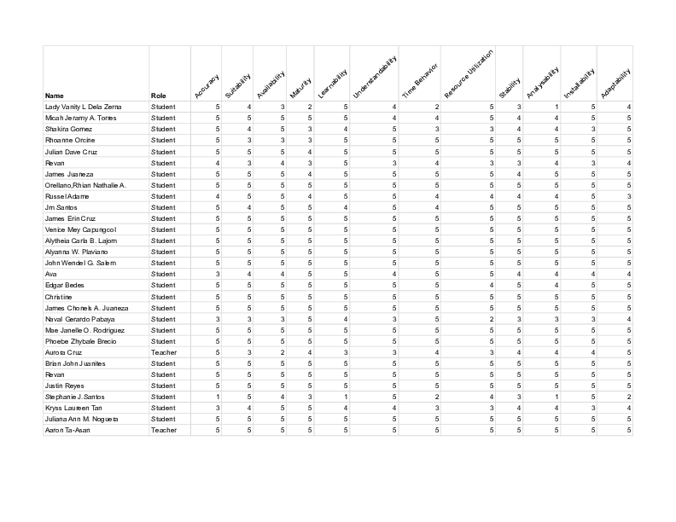

### IT Experts

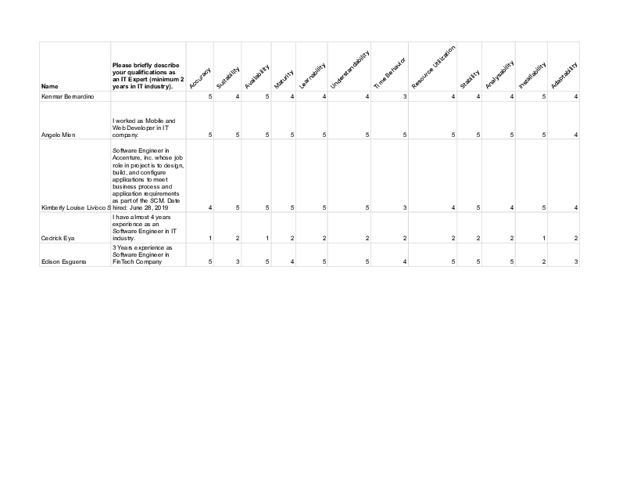

## Data Gathering Agreement Forms

### Stakeholder



### IT Experts

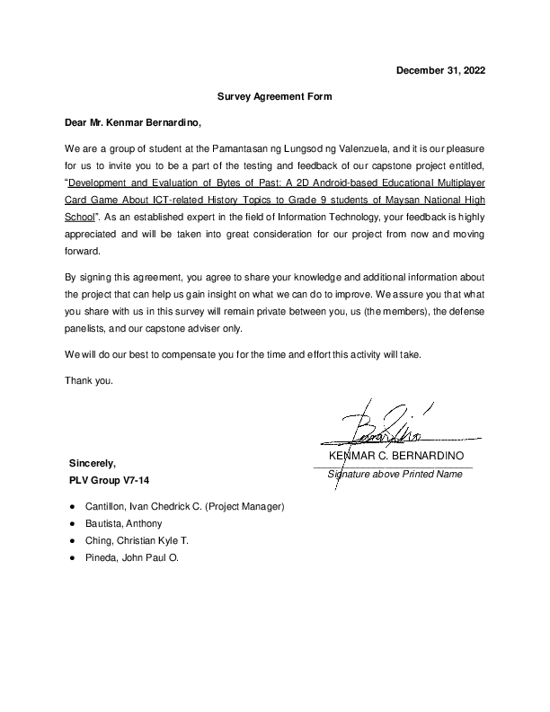

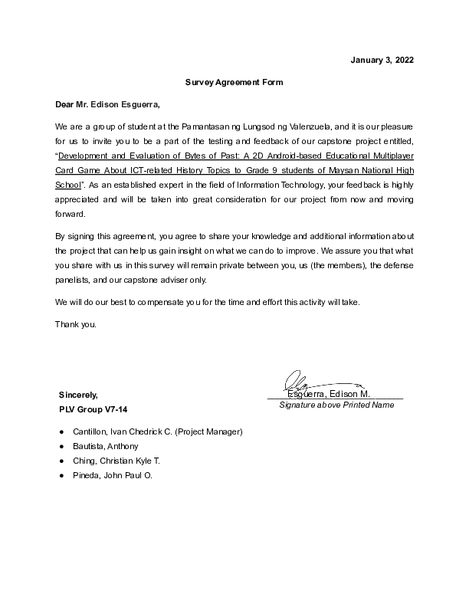

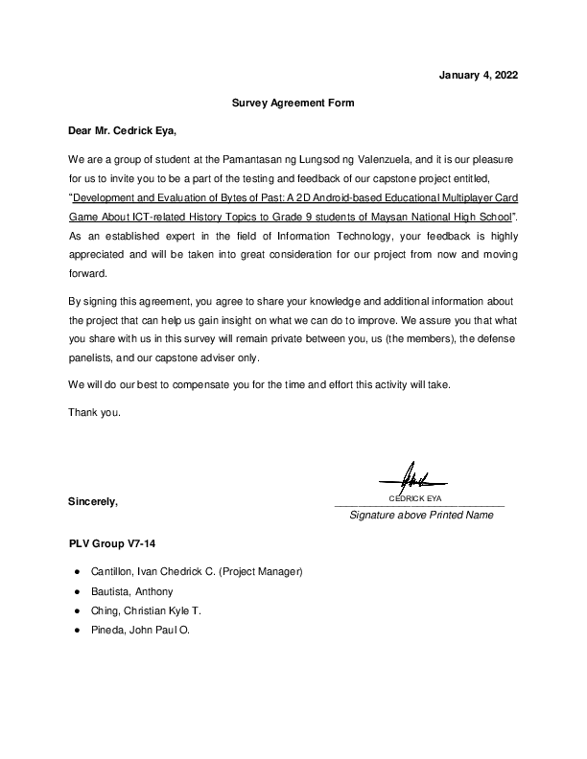



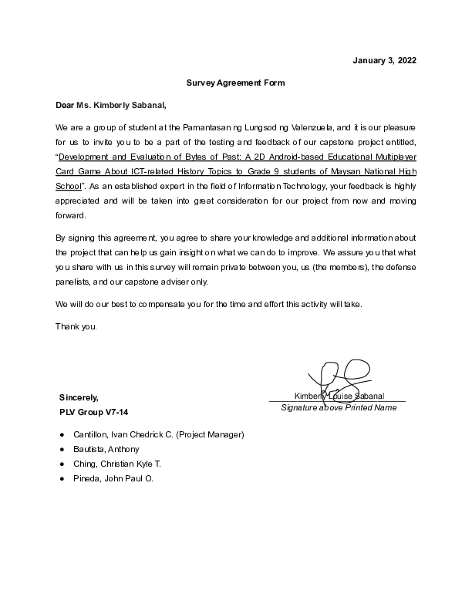

## Source Codes

### Multiplayer Game Manager (MPGameManager.cs)

using System.Collections;

using System.Collections.Generic;

using UnityEngine;

using Mirror;

using System.Linq;

using System;

public enum GameState

{

WAITING,

STARTED,

QUIZ,

FINISHED

}

public class MPGameManager : NetworkBehaviour

{

private static MPGameManager _instance;

public static MPGameManager Instance

{

get { return _instance; }

}

public GameObject cardPrefab;

// TODO: Set in prod

private int startingCardsCount = 5;

private int startingTimelineCards = 3;

private int minPlayers = 2;

private int quizIntervalRounds = 3;

private int tradeCount = 2;

public GameState gmState = GameState.WAITING;

public int turns = 0;

public int currentRound = 0;

public int currentPlayerIndex = 0;

private int readyPlayersCount = 0;

private List<CardData> cardInfos = new List<CardData>();

private List<QuestionData> questions = new List<QuestionData>();

private QuestionData currentQuestion;

public int quizAnswerCount = 0;

public List<int> deck = new List<int>(); // indices of card info

public List<int> timeline = new List<int>(); // indices of card info

public Dictionary<uint, string> winners = new Dictionary<uint, string>();

public Dictionary<uint, string> players = new Dictionary<uint, string>();

public Dictionary<uint, int> playerAvatars = new Dictionary<uint, int>();

public Dictionary<uint, int> playerTrades = new Dictionary<uint, int>();

public Dictionary<uint, List<int>> playerHands = new Dictionary<uint, List<int>>();

public HistoryTopic _topic = HistoryTopic.COMPUTER;

private StaticData _staticData;

#region ------------------------------ Init ------------------------------

private void Awake() { }

public override void OnStartServer() { }

private void LoadCards(HistoryTopic topic) { }

private void GenerateDeck() { }

private void GenerateTimeline() { }

private void LoadQuestions(HistoryTopic topic) { }

#endregion

#region ------------------------------ Player Actions ------------------------------

public void AddPlayer(NetworkIdentity nid) { }

public string RemovePlayer(NetworkIdentity nid) { }

public void ReadyPlayer(NetworkIdentity ni) { }

public void SetPlayerName(NetworkIdentity iden, string name) { }

public void SetPlayerAvatar(NetworkIdentity iden, int avatarIndex) { }

#endregion

#region ------------------------------ Game Flow ------------------------------

public void StartGame() { }

public void SetStartingCardsCount() { }

public void NextPlayerTurn() { }

public void CheckWinners() { }

public void EndGame() { }

public int PopCard(NetworkIdentity iden) { }

public List<int> PopCard(NetworkIdentity iden, int count) { }

public void OnTradeCard(uint p0Id, int p0Card, uint p1Id, int p1Card) { }

public void ShowTradeToClients(string fromPlayer, string toPlayer) { }

public bool OnPlayCard(

int infoIndex,

int pos,

NetworkIdentity iden,

bool hasDrop,

SPECIALACTION special

) { }

private bool IsDropValid(int year, int dropPos) { }

#endregion

#region ------------------------------ Remote Calls ------------------------------

public void ShowMessageToClients(

string thisTurnPlayer,

string nextTurnPlayer,

SPECIALACTION special,

bool hasDrop,

bool isDropValid,

bool doubleDrawActive

) { }

public string GetGameStateMessage() { }

public int GetCurrentRound() { }

public void CheckRound() { }

public void ClientsUpdateUI() { }

#endregion

#region ------------------------------ Utils ------------------------------

public void OnPlayerQuit(string playerName, bool isHost = false) { }

#endregion

#region ------------------------------ Special Actions ------------------------------

// TODO: Set in Prod

[Range(0f, 1f)]

private float specialActionRate = 0.3f; // 0.0 to 1.0 = Percentage of special action

public SPECIALACTION GetRandomSpecialAction() { }

public bool doubleDrawActive = false;

public bool skipTurnActive = false;

private void ApplySpecialAction(SPECIALACTION special, NetworkIdentity player) { }

#endregion

#region ------------------------------ Quiz Round ------------------------------

public void PlayQuiz() { }

[Server]

public void OnAnswerQuiz(NetworkIdentity player, string answer) { }

private void EndQuiz() { }

#endregion

}

### Multiplayer Player Manager (PlayerManager.cs)

using System.Collections;

using System.Collections.Generic;

using UnityEngine;

using Mirror;

using System;

using System.Linq;

using TMPro;

using UnityEngine.UI;

using System.IO;

public enum CARDACTION

{

Played,

Dealt

}

public class PlayerManager : NetworkBehaviour

{

private static HistoryTopic _topic = HistoryTopic.COMPUTER;

public GameObject cardPrefab;

private GameObject playerArea;

private GameObject enemyAreas;

private MPGameMessage messenger;

private GameObject gameStateText;

private GameObject activeSpecialAction;

private GameObject deck;

private GameObject dropzone;

private MPTimer timer;

private MPCanvasHUD menuCanvas;

private MPQuestionManager questionManager;

private TradingSystem tradingSystem;

private PlayerStats playerStats;

private EndGameAchievementChecker achievementChecker;

[Header("Colors")]

public Color normalTextColor = Color.white;

public Color dangerTextColor = Color.red;

public override void OnStartClient() { }

public override void OnStartLocalPlayer() { }

#region ------------------------------ LOCAL LOAD CARDS ------------------------------

[ClientRpc]

public void RpcSetTopic(HistoryTopic topic) { }

#endregion

[Command(requiresAuthority = false)]

public void CmdDrawCards(int _startingCardsCount) { }

[Command]

public void CmdReady(string playerName, int avatarIndex) { }

[Command(requiresAuthority = false)]

public void CmdGetAnotherCard() { }

public void TradeCard(uint fromPlayer, int fromCard, uint toPlayer, int toCard) { }

[Command]

public void CmdTradeCard(uint fromPlayer, int fromCard, uint toPlayer, int toCard) { }

[Command(requiresAuthority = false)]

public void CmdGetSpecificCard(int infoIndex) { }

public void PlayCard(GameObject card, int infoIndex, int pos, bool hasDrop = true) { }

[Command]

private void CmdPlayCard(

GameObject card,

int infoIndex,

int pos,

bool hasDrop,

SPECIALACTION special

) { }

[TargetRpc]

public void TargetUpdateDropStats(bool isDropValid) { }

[TargetRpc]

private void TargetDiscard(NetworkConnection conn, GameObject card) { }

[TargetRpc]

public void TargetDiscardByInfoIndex(NetworkConnection conn, int cardToRemove) { }

#region ------------------------------ UPDATE GUI FUNCTIONS ------------------------------

[ClientRpc]

public void RpcUpdateUI(

GameState gmState,

byte[] _players,

byte[] _playerHands,

string qQuestion,

string[] qChoices,

string gameMsg,

uint currentPlayerId,

int deckCount,

byte[] _winners,

byte[] _playerTrades,

byte[] _playerAvatars

) { }

public void UpdateTurn(

bool isMyTurn,

GameState gmState,

string qQuestion,

string[] qChoices,

string gameMsg,

uint currentPlayerId

) { }

[ClientRpc]

public void RpcShowDoubleDraw(bool doubleDrawActive) { }

public void UpdateOpponents(

bool isMyTurn,

GameState gmState,

uint currentPlayerId,

Dictionary<uint, string> players,

Dictionary<uint, List<int>> playerHands,

Dictionary<uint, int> playerTrades,

Dictionary<uint, int> playerAvatars

) { }

public void StartTrade(

uint playerId,

string playerName,

int[] playerHand,

uint opponentId,

string opponentName,

int[] opponentHand,

int tradesLeft

) { }

public void UpdateDeckCount(int deckCount) { }

[ClientRpc]

public void RpcShowCard(

GameObject card,

int infoIndex,

int pos,

CARDACTION type,

SPECIALACTION special

) { }

[ClientRpc]

public void RpcGameInterrupted(string playerName, bool isHost) { }

[TargetRpc]

public void TargetPeekCard(NetworkConnection conn) { }

[TargetRpc]

public void TargetDiscardRandomHand(NetworkConnection conn, int infoIndex) { }

[ClientRpc]

public void RpcShowGameMessage(string message, MPGameMessageType type) { }

[TargetRpc]

public void TargetShowQuizResult(

NetworkConnection conn,

string message,

MPGameMessageType type

) { }

#endregion

#region ------------------------------ UTILS ------------------------------

IEnumerator DestroyObjectWithDelay(GameObject obj) { }

public void SetScrollButtonsActive(bool isActive) { }

#endregion

#region ------------------------------ QUESTION MANAGER ------------------------------

public void AnswerQuiz(string answer) { }

[Command]

public void CmdAnswerQuiz(string answer) { }

#endregion

public void EndGameUpdatePlayerStats(bool gameWon) { }

}